正式公告 |深圳湾超级总部基地片区统筹开发建设与运营国际咨询
Official Announcement︱International Consultation for Overall Planning，Development and Operation of Shenzhen Bay Super Headquarters Base

- 项目背景
Ⅰ.Project Background
深圳湾超级总部基地位于深圳市华侨城南部滨海地区，是塘朗山-华侨城-深圳湾城市功能空间轴的核心区段之一。该片区南接深圳湾，与香港隔海相望，北倚华侨城内湖湿地，西邻沙河高尔夫球场，东至华侨城欢乐海岸；城市轨道2号线、9号线、11号线（机场快线）等在该片区交汇，使该片区成为环深圳湾地区自然景观条件得天独厚、城市门户形象突出、未来城市综合开发价值极高的区域。
Located in the southern coastal area of Shenzhen OCT, Shenzhen Bay Super Headquarters Base is a core segment of the Tanglang Mountain- OCT- Shenzhen Bay urban functional space axis. It adjoins Shenzhen Bay on the south, overlooking Hong Kong across the sea, with the inner lake wetland of OCT on the north, Sand River golf course on the west, and OCT Harbor on the east. Urban subway Line 2, 9 and 11 (airport express line) intersect here, making this a high value of integrated urban development area in the future with unique natural landscape resources and prominent urban gateway.
深圳湾超级总部基地片区统筹开发建设与运营国际咨询的核心范围为：滨海大道、深湾一路、深湾五路、白石三道、白石路所围合的区域，用地面积117公顷。
The core scope of International Consultation for Overall Planning，Development and Operation of Shenzhen Bay Super Headquarters Base is the area enclosed by Binhai Boulevard, Shenwan 1st Road, Shenwan 5th Road, Baishi 3rd Road and Baishi Road, with a total land area of 117 Hectares.
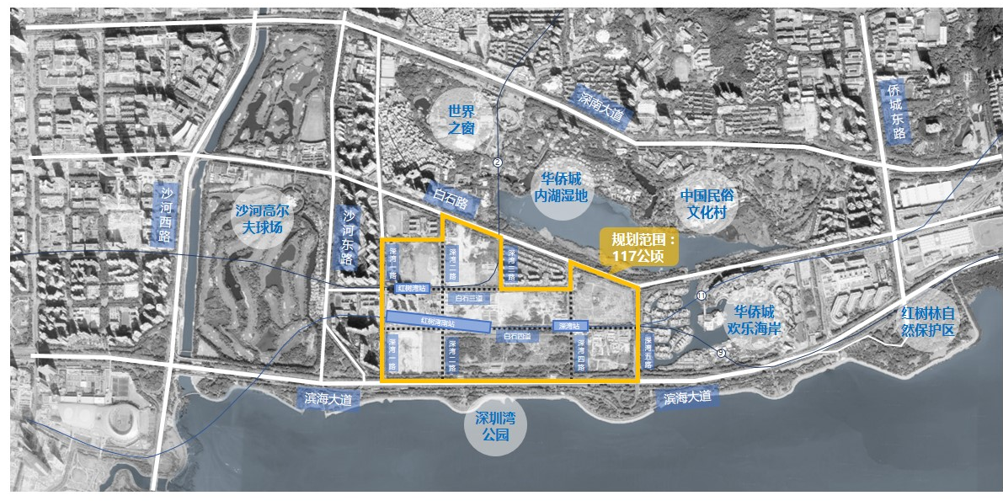
片区统筹开发建设与运营国际咨询核心范围图
Map of International Consultation for Overall Planning，Development and Operation of Shenzhen Bay Super Headquarters Base

- 工作内容
Ⅱ.Work Contents
本次国际咨询活动旨在面向世界，面向未来，以构建粤港澳大湾区世界级城市群巅峰之地为发展愿景，通过宏观环境分析,国内外案例对标,清晰定义片区的战略愿景和功能角色；并通过片区文化、商业发展规划,开发运营模式研究，空间布局及运营管理研究，推广宣传研究等，系统设计实施路径，指导片区高质高效、科学有序地开发建设和运营管理。
This international consultation is future-oriented and open for global participation. With a vision of creating a masterpiece of world-class urban cluster in the Guangdong-Hong Kong-Macao Greater Bay Area, it requests participants to distinctively define the strategic goals and functions of the area through macroscopic environment analysis, global cases benchmarking, and to guide the effective and scientific development and operation management of the area through cultural and economic development planning, development and operation patterns research, spatial layout and operation management research, marketing and promotion research, systematic design and construction methods.

- 报名要求
Ⅲ.Registration Requirements
（1）资格要求：本次咨询活动不设资质要求，国内外咨询单位均可报名参加，不接受个人名义报名。国内外报名单位应具备有效机构注册文件。
（1）Qualification Requirements: This Open Call is open to all international and local consulting firms. Registration in name of individual or group comprising individuals is not accepted. International and local applicants should have valid registration documents.
（2）经验及其他要求：具有相关咨询服务经验，鼓励具有国际知名城市、国内一线及重点城市核心区相关咨询服务经验的单位报名（证明材料不限于盖章合同封面、盖章中标通知书等，提供复印件，原件备查）。咨询服务的专题报告编制工作阶段，要求提供不少于二人驻场服务（提交报名文件即视同接受驻场服务要求，驻场费用含在咨询服务报价内）。
（2）Experience and other requirements: Consulting firms with relevant services experience, especially with international famous cities or domestic big/main cities core area relevant consulting services experience，are encouraged to sign up (The certification materials are not limited to the cover of the seal contract, sealed notice of winning etc., submission requires copied version and the original files are subjected for future reference.) No less than two people are required to provide stay-on-site service during the work stages of special report establishment for the consulting service.(The submission of the registration document is deemed to be the acceptance of the on-site service request, and the on-site service fee is included in the consultation service quotation).
（3）联合体的要求：本次咨询活动接受联合体报名，联合体家数不超过3家，但需以联合体协议书明确联合体的牵头单位和各自职责。组成项目联合体的各成员单位不得再以自己的名义单独参与投标，也不得同时加入本项目其它联合体参与投标。
(3) Requirements on consortiums: This Open Call is open to consortiums, each consortium must not include more than 3 firms, and must use ‘Consortium Agreement’ to specify the leading party and respective responsibilities. In case of joint participation, each party in the joint group cannot take part in this competition independently in its own name, or involve in any other joint groups with other design firms.

- 时间安排
Ⅳ.Time Arrangement
本次国际咨询包括资格预审、提案评审、审议定标、咨询服务四阶段。
This international consultation includes four phases, namely prequalification, proposal evaluation, proposal consolidation and consultation services.
本次国际咨询在全球范围内公开征集咨询单位参与。由资格预审委员会对报名咨询单位进行资格预审，从中择优票决选取5家入围咨询单位，参与下一阶段的提案编制。(注：若通过资格预审的入围咨询单位不足5家，主办单位将重新发布公告、组织国际咨询。入围咨询单位请提前登录深圳市工程交易服务中心http://zjj.sz.gov.cn/jsjy/咨询办理企业信息登记和数字证书，如为联合体投标，联合体各成员均需办理，具体办理流程及所需时间等详情以咨询深圳市建设工程服务中心信息为准）
由提案评审委员会对5家入围咨询单位提交的提案编制成果及现场汇报情况进行评审，确定3家不排序优胜提案单位；3家不排序优胜提案单位报深圳湾超级总部基地开发建设指挥部 (以下简称“深超总指挥部”)审议，按深超总指挥部要求依照有关程序定标确定第一名中标单位；由第一名中标单位完成本项国际咨询的全部工作内容，工作过程中需配合参与沟通协调会议及进行阶段成果汇报等。
This international consultation is open to all consulting firms worldwide. The Pre-qualification Committee will assess the registered consulting firms and shortlist 5 of them to proceed with the project services in the next phase.(Note: if the number of the consulting firms passed pre-qualification is less than 5, the sponsor will re-release the announcement and organize international consultation. The 5 shortlisted consulting firms shall log in Shenzhen Engineering Transaction Service Center http://zjj.sz.gov.cn/jsjy/ for enterprise information registration and digital certificates in advance. For joint bidding, all members of the consortium shall go through the registration and digital certificates. consulting firms could refer to Shenzhen Construction Engineering Service Center for details of the procedures and time required.)
The Proposal Evaluation Committee will evaluate the proposals submitted by these 5 firms and select 3 non-ranking winning proposals; the Shenzhen Bay Super Base Construction Headquarters will evaluate all 3 non-ranking winning proposals, the first bid-winning firms will be determined according to the relevant procedures and requirements. The first bid-winning firms will complete all the consulting work contents of this project, meanwhile participate in the communication & coordination meeting and give needful research output reports to Shenzhen Bay Super Base Construction Headquarters during work process.
中标单位在完成经深超总指挥部审定的专题报告后持续提供必要的专业服务，服务期限至完成专题报告后满一年，其中包含参加主办单位或承办单位组织的包含但不限于工作坊、专家研讨会、沟通协调会等，次数不多于六次。
Bid-winning firms are expected to continuously provide necessary professional services after the completion of the special report approved by the Shenzhen Bay Super Base Construction Headquarter. Professional services are expected within one year after the conclusion of consultations, participation of, including but is not limited to, workshops, expert seminars, communication and coordination meetings organized by Organizer or Co-organizer no more than 6 times.
时间安排详见下表（时间为暂定）：
Schedule ( tentative)

阶段  Phase | 时间  Deadline | 事项  Activities
第一阶段  资格预审  Phase 1  Pre-qualification | 2019年6月26日（周三）  June 26 2019 (Wed) | 发布正式公告、咨询要求和工作规则  Release of official announcement and Consultation Brief
第一阶段  资格预审  Phase 1  Pre-qualification | 2019年7月8日（周一）  July 8 2019 (Mon) | 提交电子报名资料  Deadline for submitting electronic registration materials
第一阶段  资格预审  Phase 1  Pre-qualification | 2019年7月11日（周四）  July 11 2019 (Thu) | 提交纸质报名资料，报名截止（本次咨询以收到纸质报材料为准）  Submission of paper registration materials (the effectiveness of registration is subject to the receipt of the paper documents)
第一阶段  资格预审  Phase 1  Pre-qualification | 2019年7月15日（周一）  July 15 2019 (Mon) | 由资格预审委员会对报名材料进行资格预审，从中筛选出5家入围咨询单位。  Assessment of the registration materials by the Pre-qualification Committee to shortlist 5 consulting firms to proceed with the subsequent phase.
第一阶段  资格预审  Phase 1  Pre-qualification | 2019年7月16日（周二）  July 16 2019 (Tue) | 公布资格审查结果，发出入围通知书及技术任务书  Announcement of pre-qualification results and distribution of Shortlist Notice and Technical Assignment Book
第二阶段  提案评审  Phase 2  Proposal Evaluation | 2019年7月23日（周二）  July 23 2019 (Tue) | 书面提交质疑问题截止时间  Deadline for submitting questions in written form
第二阶段  提案评审  Phase 2  Proposal Evaluation | 2019年8月12日（周一）  August 12 2019 (Mon) | 提交提案编制成果  Submission of proposal preparation deliverables
第二阶段  提案评审  Phase 2  Proposal Evaluation | 2019年8月15日（周四）  August 15 2019 (Thu) | 召开提案评审会，择优票决选出3家不排序优胜提案单位  Proposal evaluation meeting, choose 3 non-ranking winning firms
第二阶段  提案评审  Phase 2  Proposal Evaluation | 2019年8月16日（周五）  August 16 2019 (Fri) | 提案评审结果公布  Announcement of evaluation results
第三阶段  审议定标  Phase 3  Proposal Consolidation | 2019年8月下旬  Late August 2019 | 召开定标会，确定第一名中标单位  Proposal consolidation meeting and finalize first place, bid-winning firms
第三阶段  审议定标  Phase 3  Proposal Consolidation | 2019年9月上旬  Early September 2019 | 发布最终评审结果  Announcement of the final evaluation results
第四阶段  咨询服务  Phase 4  Consulting Service | 2019年9月-2021年1月  Sep. 2019 - Jan. 2021 | 完成本次国际咨询的所有专题报告以及后续服务全部工作内容  Completeness of all special reports of this open call and all the work contents afterwards
注：上表均为北京时间，主办单位保留调整日程安排的权利。
Note: Time stated above is Beijing Time and host reserves the rights to adjust the schedule.

- 咨询合同签署方式及费用
Ⅴ.Means of signing consulting contracts and fees
本次国际咨询合同签署方式及费用如下：
The means and fees of signing this international consulting contract are as follows:
第一名中标单位与承办单位签署咨询服务合同（若中标单位为联合体，则联合体各成员单位共同与承办单位签署咨询服务合同），合同金额为其咨询服务报价。
The first bid-winning firm signs a consulting service contract with the Organizer (if the bid-winning firm is a consortium, each member of the consortium signs a consulting service contract with the organizer), and the contract price will be the same as the quotation price.

- 资料索取及联络
Ⅵ.Information Request and Contact
资料下载：
Download:
附件1：第一部分：工作规则
Appendix 1: Part I Working Rules
附件2：第二部分：咨询要求
Appendix 2: Part II Consultation Requirements
咨询电话：史先生 0755-83500229（+86 15099910515）
邮箱：sztc@sztc.com
E-Mail:sztc@sztc.com
- 组织机构
Ⅶ.Organizer
主办单位：深圳湾超级总部基地开发建设指挥部办公室
Organizer: Shenzhen Bay Super Base Construction Headquarters Office
承办单位：深圳市投资控股有限公司
Co-Organizer: Shenzhen Investment Holdings Co., Ltd.
技术服务单位：深圳湾超级总部基地总设计师团队
Technical Support: Shenzhen Bay Super Base Chief Design Team
国际咨询公告发布平台：深圳市建设工程交易服务网
（http://zjj.sz.gov.cn/jsjy/）
Internet Announcement Platform: Shenzhen Construction Project Transaction Service Network （http://zjj.sz.gov.cn/jsjy/）
组织服务单位：深圳市国际招标有限公司
Organization Support: Shenzhen International Bidding Co., Ltd.

