深圳湾超级总部基地
片区统筹开发建设与运营国际咨询
International Consultation for Overall Planning，Development and Operation of Shenzhen Bay Super Headquarters Base
咨询要求
Consultation Requirements

深圳湾超级总部基地开发建设指挥部办公室
Shenzhen Bay Super Base Construction Headquarters Office
二〇一九年六月
June.2019
目录
Table of Contents

一、 工作背景 1
Ⅰ. Project Background 1
二、 工作目标 10
Ⅱ. Work Objectives 10
三、 工作范围 11
Ⅲ. Work Scope 11
四、 工作内容 11
Ⅳ. Work Contents 11
五、 成果构成 19
Ⅴ. Project Submissions 20

- 工作背景

Ⅰ. Project Background

（1）项目概况

（1）Project Introduction
深圳湾超级总部基地位于深圳市华侨城南部滨海地区，是塘朗山-华侨城-深圳湾城市功能空间轴的核心区段之一。该片区南接深圳湾，与香港隔海相望，北倚华侨城内湖湿地，西邻沙河高尔夫球场，东至华侨城欢乐海岸；城市轨道2号线、9号线、11号线（机场快线）等在该片区交汇，使该片区成为环深圳湾地区自然景观条件得天独厚、城市门户形象突出、未来城市综合开发价值极高的区域。
Located in the southern coastal area of Shenzhen OCT, Shenzhen Bay Super Headquarters Base is a core segment of the Tanglang Mountain- OCT- Shenzhen Bay urban functional space axis. It adjoins Shenzhen Bay on the south, overlooking Hong Kong across the sea, with the inner lake wetland of OCT on the north, Sand River golf course on the west, and OCT Harbor on the east. Urban subway Line 2, 9 and 11 (airport express line) intersect here, making this a high value of integrated urban development area in the future with unique natural landscape resources and prominent urban gateway.
为实现构建粤港澳大湾区世界级城市群巅峰之地的发展目标，按照市委市政府对该片区高品质、高标准开展规划、设计、建设和管理的要求，建立统筹协调、形成合力、强力推进的规建管一体化体制机制，加强指挥决策领导管理，深圳市政府特此成立了深圳湾超级总部基地开发建设指挥部（以下简称“深超总指挥部”）作为统筹协调单位，设立深圳湾超级总部基地开发建设指挥部办公室（以下简称“深超总办公室”）处理具体日常事务,并确定深圳市投资控股有限公司（以下简称“市投控公司”）作为深圳湾超级总部基地片区的统筹开发运营实施主体。
With a vision to create a pinnacle of world-class urban cluster in Guangdong-Hong Kong-Macao Greater Bay Area, in accordance with the requirements from Shenzhen Municipal Party Committee and the Municipal Government for high-quality, high-standard planning, design, construction and management on this area, a systematic integration of planning, construction and management was established to strengthen decision-making and leadership by Shenzhen Municipal Government through the founding of the Shenzhen Bay Super Base Headquarters (hereinafter referred to as the SSBH) as the overall management and coordination entity , the Shenzhen Bay Super Base Headquarters Office (hereinafter referred to as the SSBHO) as the deputy entity for in-depth management, and the appointment of Shenzhen Investment Holdings Co., Ltd. ( hereinafter referred to as the SIHC) as the development and management entity for Shenzhen Bay Super Headquarters Base area.
本片区设有城市设计优化、片区综合交通提升规划与交通详细规划、片区统筹开发建设与运营、智慧城市研究、地下空间及市政工程规划、中央绿轴景观规划等专项研究工作。目前城市设计优化与片区综合交通提升规划与交通详细规划已于2018年开展并将完成最终成果。其他专项正同步进行国际咨询或招标工作，片区统筹开发建设与运营国际咨询中标单位将与其它专项研究团队协同工作。
This area is composed by special research programs: urban design optimization, comprehensive regional transportation improvement planning and detailed transportation planning, overall regional development and operation, smart cities study, underground space and municipal projects planning, central green axis landscape planning and etc.. Urban design optimization and comprehensive regional transportation improvement planning and detailed transportation planning have started in 2018, while other special research programs are open for international consultation and bidding. The bid-winning firm on overall development and operation international consultant will work together with all the special research program teams.

（2）项目历程

（2）Course of Planning
2001年原深圳市规划局开展了《华侨城南填海区详细蓝图》编制工作，十数年内对华侨城南填海区进行了持续的城市设计方案修改工作，从原有单一的“滨海城市住区”（2001年）到复合的“滨海文化商务中心”（2004年）再到“超级总部基地”（2007年），从单纯的城市空间设计发展到城市生活方式的引导。
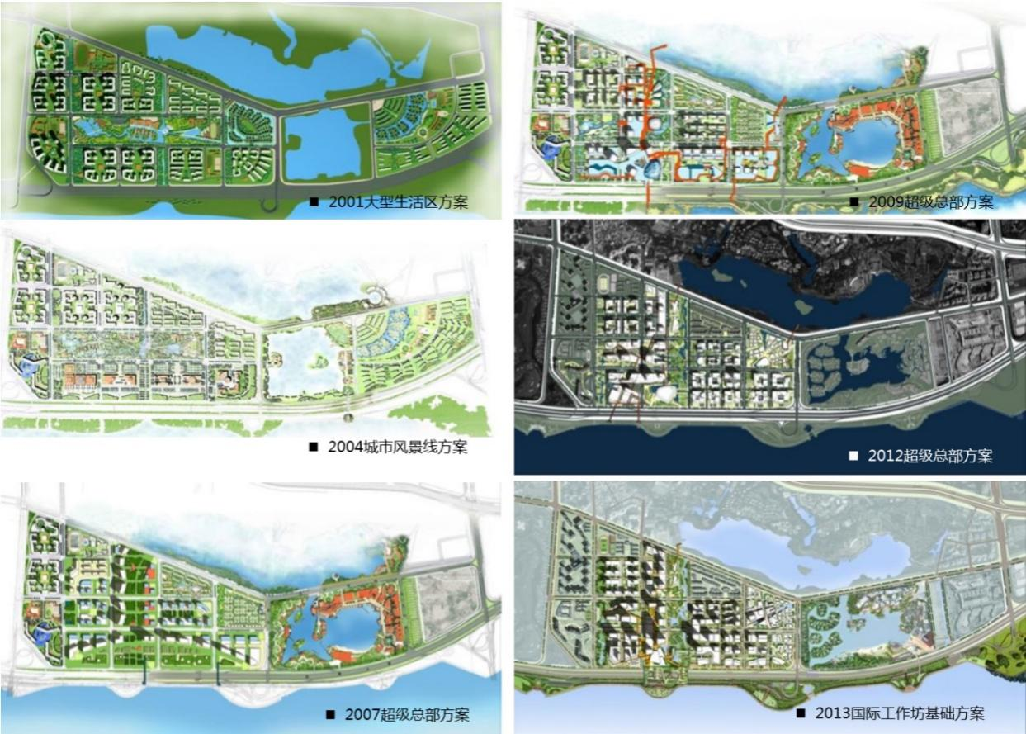
In 2001, the former Urban Planning Bureau of Shenzhen conducted the editing on Detailed Blueprint of the Reclamation Area in the South of OCT. By offering dynamic tracing service, the former Urban Planning Bureau of Shenzhen has been reviewing and revising their urban design plans in their service period in the past 10 plus years. The positioning has been revised from the original simplex “coastal urban residential area”(in 2001) to the mixed-use “coastal cultural and commercial center”（in 2004) and finally to the “super headquarters base”(in 2007), witnessing changes from simple urban spatial design to the concept of leading urban life style. It thus laid a solid foundation for the social objectives and spatial structure of urban design.
图1规划历程
Fig.1 Course of Planning
2011年原深圳市规划和国土资源委员会重新启动了对该地区的规划设计研究工作，开展了《深圳湾超级总部基地控制性详细规划》。作为深圳未来城市建设的实验展示性地区，建议将生态低碳城市构想、数字城市技术等新科技综合融入深圳湾填海区，与后海中心区形成良性互动。该规划于2014年3月14日，获深圳市政府五届一百零五次常务会议原则通过。
In 2011, the former Shenzhen Urban Planning, Land and Resources Commission restarted the planning and design of the area and conducted the Regulatory Detailed Plan of Shenzhen Bay Super Headquarters Base. It proposes to incorporate ecological and low-carbon city concept, digital city technology and other new technologies into Shenzhen Bay Reclamation Area, which serves as an experimental demonstration area for future urban development of Shenzhen, for positive interactions with Houhai Central District. The regulatory detailed plan was approved on March 14, 2014 in the 105th session of the 5th Standing Meeting of the Shenzhen Municipal Government.
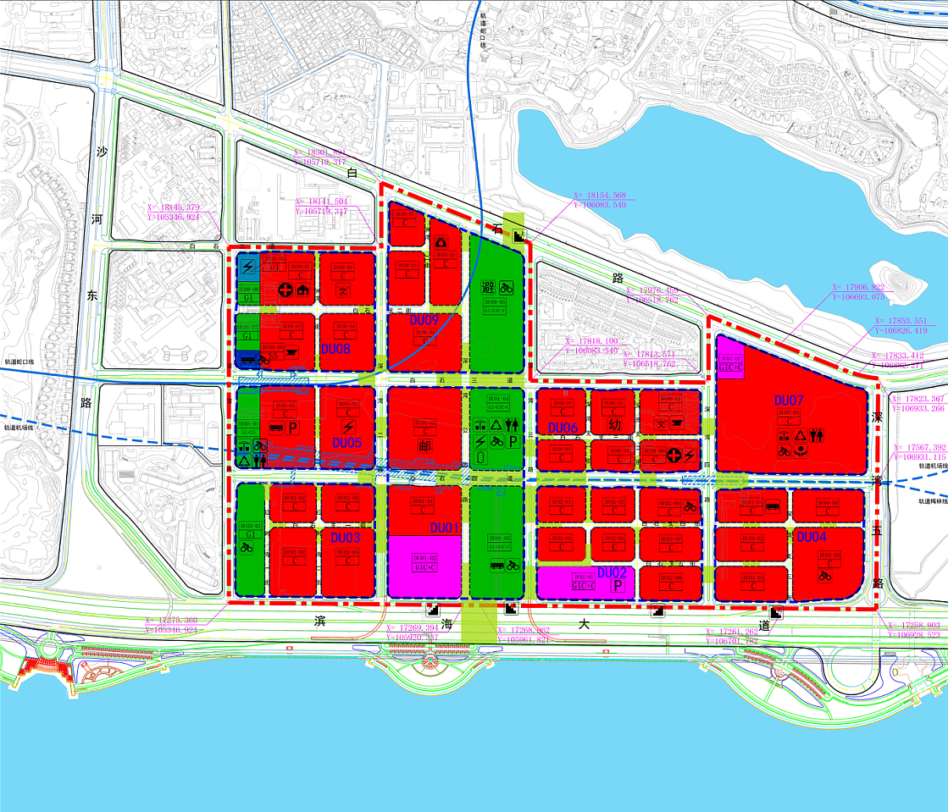
图2深圳湾超级总部基地控制性详细规划2014版
Fig.2 Regulatory Detailed Plan of Shenzhen Bay
Super Headquarters Base (2014)
2013年和2014年，在当时的规划研究成果基础上，原深圳市规划和国土资源委员会开展了深圳湾超级总部基地国际工作坊和超级总部核心区概念方案的国际竞赛，集思广益提出了极富想象力及创造性的未来城市建设概念，也使得本片区的公众关注度及国际知名度进一步提升。2018年，为了对该片区提出更具创意与国际视野的深化、优化设计工作，深超总办公室开展了深圳湾超级总部基地城市设计优化、片区综合交通提升规划与交通详细规划两项国际咨询活动，对片区的布局结构、开发强度、功能构成、公共空间、建筑风貌、生态景观、城市天际线、综合交通、地面道路、地下道路、轨道规划等内容进行系统性设计，指导片区高质高效、科学有序的开发建设和运营管理。
In 2013 and 2014, based on the existing results of planning and research at that time, the former Shenzhen Urban Planning, Land and Resources Commission organized the Shenzhen Bay Super Headquarters Base International Workshop and an international competition on the conceptual plan of the core area of Shenzhen Bay Super Headquarters Base. These activities helped solicit ideas from all walks of life to refine and detail the design in terms of creativity and international vision. In these activities, imaginative and creative construction concepts of future cities were proposed which helped boost the public attention to and international reputation of this area.In 2018, Open Call for Urban Design Optimization of Shenzhen Bay Super Headquarters Base and Comprehensive Transportation Improvement Planning and Detailed Transportation Planning were hosted by the SSBHO to systematically design of the layout structure, development strength, functional composition, public space, architectural style, ecological landscape, city skyline, integrated transportation, ground-level roads, underground roads, urban railway planning are required to strengthen lean planning control of spatial form and guide orderly development and construction of the area.
目前，上述两项国际咨询正进行优化整合，计划于6月底形成最终成果。
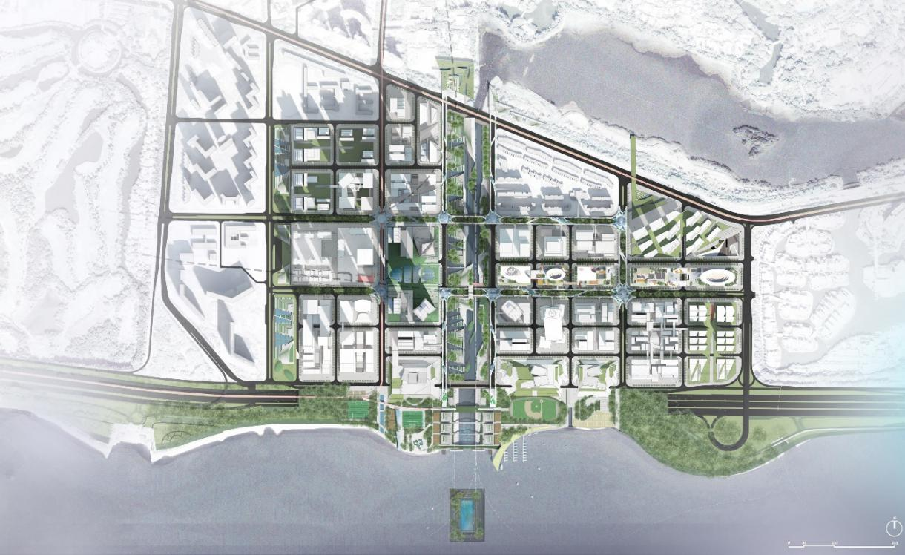
At present, the two international consultations stated above are under optimization and integration, and the achievement will be revealed by the end of June.
图3深圳湾超级总部基地城市设计优化国际咨询中标方案总平面图
Fig.3 Winning Proposal of International Consultation on Urban Design Optimization of Shenzhen Bay Super Headquarters Base.

（3）现状条件

（3）Existing Site Conditions
深圳湾超级总部基地位于深圳湾北面，华侨城地区南部，是塘朗山-华侨城-深圳湾城市功能空间轴的核心城市功能区段之一。深圳湾由西至东布局了蛇口地区、西部通道口岸、后海中心区、高新区和华侨城地区。根据最新深圳市城市总体规划，环深圳湾地区将成为粤港澳大湾区最重要的城市地区之一，成为激发深圳跻身全球一流城市的能量起点。
Located in the north of Shenzhen Bay and in the south of OCT, Shenzhen Bay Super Headquarters Base is a core segment of the Tanglang Mountain-OCT-Shenzhen Bay urban functional space axis. Shekou area, West Corridor port, Houhai Central District, High-Tech Zone and OCT area are included in the layout of Shenzhen Bay from the west to the east. According to the latest master plan of Shenzhen, Shenzhen Bay rim will become one of the most crucial urban area in the Guangdong-Hong Kong-Macao Greater Bay Area, and a base powering Shenzhen’s efforts to be a first-tier city in the world.
目前，按照深圳市委市政府的工作部署，深圳湾超级总部基地已进入加速建设实施阶段，除早期联泰返还用地项目、地铁上盖投融资项目（深湾汇云中心）外，近年来已出让了中信证券、招商银行、天音通信、碳云智能、恒力、中国电子、中兴通讯、神州数码、万科、恒大和欧加通信11个项目，已出让土地面积约共41.2公顷，上述用地已占到规划总用地的35%左右。
Currently, according to the work deployment of the Shenzhen Municipal CPC Committee and the Municipal Government, Shenzhen Bay Super Headquarters Base has ushered in a stage of accelerated construction. Besides the early land return project of Liantai Group and the investment and financing project located above the subway station (Shenzhen Bay Huiyun Center), a total land area of 41.2 hectares has been assigned to eleven projects in recent years, including Citic Securities, China Merchants Bank, Telling Telecommunication, iCarbonX, Hengli Group, China Electronics, ZTE, Digital China, Vanke, Evergrande and Oppo, accounting for 35% of the total planned land use area.
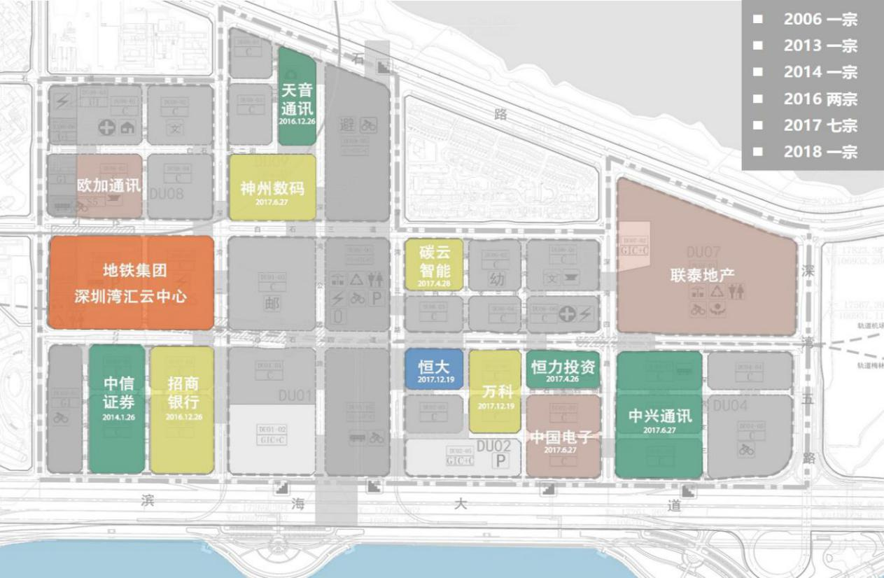
图4土地出让情况图
Fig.4 Current Land Assignment

- 工作目标

Ⅱ. Work Objectives
深圳湾超级总部基地片区统筹开发建设与运营国际咨询活动旨在面向世界，面向未来，以构建粤港澳大湾区世界级城市群巅峰之地为发展愿景，通过宏观环境分析,国内外案例对标,清晰定义片区的战略愿景和功能角色；并通过片区文化、商业发展规划,开发运营模式研究,空间布局及运营管理研究，推广宣传研究等,系统设计实施路径，指导片区高质高效、科学有序地开发建设和运营管理。
International Consultation for Overall Planning，Development and Operation of Shenzhen Bay Super Headquarters Base is future-oriented and open for global participation. With a vision of creating a masterpiece of world-class urban cluster in the Guangdong-Hong Kong-Macao Greater Bay Area, it requests participants to distinctively define the strategic goals and functions of the area through macroscopic environment analysis, global cases benchmarking, and to guide the effective and scientific development and operation management of the area through cultural and economic development planning, development and operation patterns research, spatial layout and operation management research, marketing and promotion research, systematic design and construction methods.

- 工作范围

Ⅲ. Work Scope
本次国际咨询的核心研究范围为：滨海大道、深湾一路、深湾五路、白石三道、白石路所围合的区域，用地面积117公顷。
The core scope of this international consultation is the area enclosed by Binhai Boulevard, Shenwan 1st Road, Shenwan 5th Road, Baishi 3rd Road and Baishi Road, with a total land area of 117 Hectares.
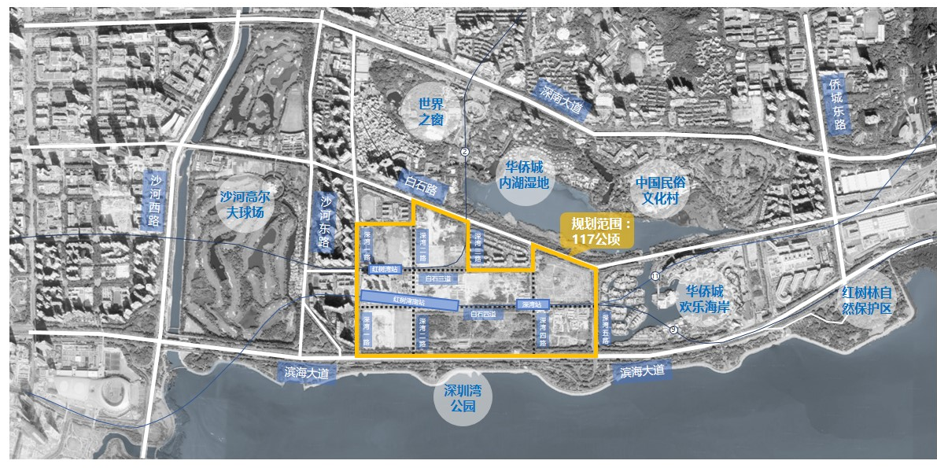
图5本次国际咨询核心研究范围图
Figure 5: The core scope of this international consultation

- 工作内容

Ⅳ. Work Contents
本次国际咨询活动，结合目前已出让土地的规划设计情况，与片区其他专项研究团队协同工作，充分对接，提出片区开发建设及运营的综合解决方案。具体工作应包括但不限于以下内容：
The participants of this international consultation should work with other special research teams and propose wholistic and integrated solutions for overall planning, development and operation of this area, based on the current land use and planning design. The final contents should include but not limit to the followings:

（1）宏观环境分析

（1）Macro Environment Analysis
分析全球经济和科创的发展形势及重大机遇,系统研究国家及地方政策，重点关注粤港澳大湾区发展及深圳城市能级跃升的痛点和需求；梳理城市核心区经济，如金融、科创、商务等潜在目标产业上位规划和政策导向，分析发展趋势、发展特点和产业布局等；调研政府相关部门需求、世界500强企业及“独角兽”等创新性企业的发展需求；调研片区内入驻企业的项目定位、发展规划以及对区域协同发展的诉求。
Analysis of global trends and major opportunities of economy, technology and creative industry, systematic research of national and local policies with focuses on Guangdong-Hong Kong-Macao area, understanding Shenzhen’s pain points and needs of urban upgrades; sorting out economy system of urban core area, such as preliminary planning and policy guidance of financial industry, creative and technological industry, business development and other potential industries, analysis of trends, development features and industry distributions; Research on the future needs of related governmental entities, Fortune 500 companies, “Unicorn” enterprises and other creative industries; Research on the project positioning, future planning and needs of perspective incoming enterprises of this area.

（2）国内外案例对标借鉴

（2）Benchmarking Domestic and Global Developments
对标国内外案例，包含但不限于全球能级的城市核心区、金融商务区、高能级湾区等（如金丝雀码头、纽约哈德逊广场、纽约湾区、东京湾以及国内城市核心区等），研究案例的目标定位、产业及城市功能、空间分区、运作模式、载体业态、空间布局、政策环境等。重点借鉴先进的城市发展理念、经济辐射引领效应、城市特质及文化底蕴彰显、国际交往、湾区发展路径、核心区运营管理模式等方面的经验和教训。
Benchmarking domestic and global developments, including but not limiting to world-class urban core district, financial and business centers, high-level bay area development (such as Canary Wharf, New York Hudson Yard Development, New York Bay Area Development, Tokyo Bay Area Development and other domestic urban core area developments), research on their development objectives and positioning, industry and urban programs, zonings, operation models, business, spatial arrangements, political environment and etc. Research focuses should be given to advanced urban development concepts, leading effects of economical influences, urban features and cultural development, international connections, course of development of bay areas, operation models of core districts and other related experiences.

（3）片区发展战略定位及推广宣传研究

（3）Research on Regional Development Strategies, Positioning and Marketing
综合宏观环境分析，结合对标案例研究，全面梳理片区资源禀赋及优劣势；同时研究深圳其他重点片区及粤港澳大湾区其他城市核心片区发展策略，定义深圳湾超级总部基地与其它片区竞争和协同关系，总结深圳湾超级总部基地的差异化竞争点；清晰定义片区的功能角色，精确解读“巅峰之作”的内在含义及其外延,为片区提出明确战略愿景、定位，设计实施路径。提出国际化推广宣传建议，提升整体项目和城市的国际影响力和全球美誉度。
Based on Macro environmental analysis and benchmarking research, wholistic analysis of regional resources, advantages and disadvantages; research on development strategies of other key districts of Shenzhen and core areas of other cities of Guangdong-Hong Kong-Macao Greater Bay Area, defining competitive and collaborated relationship between Shenzhen Bay Super Headquarters Base and other key districts, stating the competitive differentiation of Shenzhen Bay Super Headquarters Base; Clearly defining the role of each sub-districts, with precise interpretation of the core concept of “masterpiece of world-class urban cluster” and its conceptual extensions, clearly stating the strategic vision, positioning, and design implementations of this area. Propose international marketing strategies in order to increase the global influences and reputation of the project and the city.

（4）片区发展、城市功能、空间布局及运营管理建议

（4）Suggestion on Regional Development, Urban Functions, Spatial Layout and Operations and Managements
基于深圳湾超级总部基地战略定位，为潜在入驻企业和主要服务人群画像，深入了解目标企业及人群需求；研究未来重点发展产业和导入的城市功能及公共文化设施配套；与城市设计优化、片区综合交通提升规划与交通详细规划、智慧城市研究、地下空间规划、市政工程规划、中央绿轴景观规划等专项研究团队协同工作，落实产业和城市功能的空间落位、不同功能业态配比等；研究地上地下运营管理界面划分，提出所需导入资源建议和运营管理建议。
User profiling of prospective enterprise tenants based on strategic positioning of Shenzhen Bay Super Headquarters Base and in-depth research of demands from targeted enterprise and users; research on future key development industries, anchored urban programs and public cultural facilities; Collaborating with research team on urban design optimization, comprehensive regional transportation improvement planning and detailed transportation planning, smart cities study, underground space planning, municipal projects planning, central green axis landscape planning, finalizing spatial placement of industries and urban programs, composition ratio of different business formats; Research on aboveground and underground operation and management interface, propose necessary resources and suggestion on operations and managements.

（5）中央绿轴、地标地块及地上地下公共区域专项研究

（5）Special Research on Central Green Axis, Landmark Plot and Public Space in Both Aboveground and Underground
重点分析中央绿轴、地标地块及地上地下公共区域的功能业态，提出文化主题塑造建议；研究中央绿轴等公共区域与周边项目的协同关系，提出开发运营方案建议，充分发挥其区域带动作用和辐射作用；提供公共空间产权政策建议；提出公共区域及24小时街区的实施范围及运营管理建议。
Key analysis on central green axis, landmark plot and public space in both aboveground and underground, with suggestions on shaping cultural features; Research on synergistic relationship between public space, such as the central green axis, and other areas of the project, giving suggestions on development and operation schemes which can optimize its regional influences and regional driven role; Advising on property rights policy on public space; Advising on implementation scope and operations of public area and 24-hr neighborhood.

（6）片区文化、商业发展规划

（6）Planning on Regional Cultural and Business Development
从片区周边范围、南山区、深圳市乃至粤港澳大湾区整体发展趋势及现状进行分析，统筹考虑本片区的文化、商业布局及运营策略，实现片区内产品类型多元化，形成集聚优势，避免同质化竞争。从片区公共配套服务功能考虑，确定片区文化、商业整体功能定位，包括辐射范畴、服务对象、业态需求、与其他功能区的互补关系；根据服务对象、人流来源，提出布局建议及招商策略。针对片区公共文化建筑提出项目类别、建设规模、运营策略等分析建议；针对已出让及未出让地块项目，提出其文化及商业建设指标的功能、类别、业态、运营管理等建议，作为单个项目相关设计、审批的参考依据。
Analysis of the overall development trend and existing conditions from the surroundings of the site, Nanshan District, Shenzhen City, and Guangdong-Hong Kong-Macao Greater Bay Area, Overall consideration of operational strategies for culture and business distributions, diversifying product types in the region, forming agglomeration advantages and avoiding homogenization competitions. From the perspective of the public supporting programs, positioning cultural and commercial program for this area, including its effective range, service targets, business requirements, and complementary relationship with other programs and areas; Providing strategies on business layout and leasing. Based on assigned and unassigned land plots, advising on construction volume quotas related to function, category, format, operation management and etc. of cultural and commercial programs for relevant design and approval reference of each individual design scheme.

（7）片区开发运营实施策略

（7）Implementation Strategies on Regional Development and Operations
开发模式研究，通过研究与本片区相类似的国际、国内现有案例开发建设模式，提出政府、市投控公司及入驻企业等在片区统筹开发建设中的角色分工和协作机制。运营管理策略，设计多种“1+N”国际化的片区运营平台搭建方案，并进行对比分析；结合功能定位、配套服务、招商营运等方面提出片区的运营管理策略，包括但不限于招商服务、营商环境、城市服务等。机制创新研究，如土地出让遴选方案和相关标准、多方资源合作机制创新、招商服务政策创新、规划执行落地保障机制创新等。开发时序策略，梳理片区统筹建设内容，提出片区土地出让、开发时序等策略建议，保证公共系统建设（如地下空间、道路、市政等）与单个地块建设有效衔接，并编制片区十年发展纲要。
Development Models Research: Based on case study of development mode of similar global and domestic developments, propose role divisions and collaboration mechanisms between government entity, Shenzhen Investment Holdings Co., Ltd. and prospective enterprise tenants in this regional development. Operation and Management Strategies: Design and compare multiple “1+N” global platform construction solutions on regional operations; Propose strategies on regional operations and managements in program positionings, supporting services and leasing and operations, including but not limiting to leasing services, business environment, city services etc. Mechanism Innovation Research: Includes but not limits to land transfer selection plan and related standards, innovation on collaboration mechanism between multiple contributors, innovation on investment service policy, innovation on planning implementation mechanism etc. Development Sequence Strategies: sort out overall development contents of this region, advise on land assignment and development sequence and strategy, ensure smooth transition between infrastructure construction (underground space, roadworks and municipal projects) and individual plots, and prepare 10-year development plan for the region.

（8）片区财务测算

（8）Financial Projection of Regional Development
建立产业经济测算模型，预测整个片区的产值、税收、就业、科研等不同维度的产出情况，测算片区整体的产业经济效益和社会效益;根据项目综合开发方案，建立基础设施、公共配套及核心项目财务测算模型，对项目开发的经济成本和预期收益进行测算，分析政府和开发企业的经济成本和收益情况。
Establish financial model for industrial economy, forecasting financial output from production, taxation, employment, research etc., measure the industrial economic benefits and social benefits of the area; establish financial projection models for infrastructure development, public services and core development projects, cost-benefit analysis for project developments, and cost-benefit analysis for government and developer.

- 成果构成

Ⅴ. Project Submissions

（1）提案编制成果（明标）

（1）Project proposal(open bid)
根据粤港澳大湾区发展规划、深圳市功能定位和发展形势，结合深圳湾超级总部基地实际情况，以及本次国际咨询工作内容要求，提案编制成果应包括但不限于以下方面（格式自定）：
According to the development plan of the Guangdong-Hong Kong-Macao Greater Bay Area, the functional orientation and development situation of Shenzhen, the actual situation of Shenzhen Bay Super Headquarters Base and the work Contents of this international consultation, the results of the project proposal should include but not limit to the following contents (the format to be determined by the consulting firm):
1)对项目的理解；
1）Understanding of the Project;
2）对工作任务及工作目标的理解；
2)Understanding of the work tasks and objectives;
3）工作方案；
3）Work proposal;
4）团队服务能力；
4）Team performance;
5）进度计划；
5）Proposal schedule;
6）服务承诺；
6）Service Commitment;
7）投标人认为对投标有利的其他资料。
7）Other materials deemed useful by the bidder.

（2）咨询服务报价

（2）Consulting service quotation
注：本次咨询服务报价不得超过800万元人民币的上限，否则视为无效报价。
Note：The quotation of this consulting service should not exceed 8 million RMB. Quotation exceeds this number will be voided.
项目名称：深圳湾超级总部基地片区统筹开发建设与运营国际咨询
Project Name: International Consultation for Overall Planning，Development and Operation of Shenzhen Bay Super Headquarters Base
序号  No. | 内容  Contents | 咨询服务报价（人民币：万元）  Consulting service quotation（CNY: in ten-thousand Yuan） | 备注  Note
1 | 深圳湾超级总部基地片区统筹开发建设与运营咨询服务  Consulting service Overall Planning，Development and Operation of Shenzhen Bay Super Headquarters Base | 小写：  In number:  大写：  In text:
说明：
Instructions:
1、最终获得第一名的中标单位，其报价即为深圳湾超级总部基地片区统筹开发建设与运营国际咨询的服务合同价。
1. The quotation of the bid-winning firms will be the contract price of International Consultation for Overall Planning，Development and Operation of Shenzhen Bay Super Headquarters Base.
2、咨询服务报价作为评审依据之一，本项目不承诺最低价中标。
2. Quotation is one of the basis for evaluation, and this project does not promise the lowest price bid is the winning bid.
3、咨询服务报价大小写数字不一致的，以大写数字为准。
3. If there is inconsistence between quotation in number and quotation in text, the quotation in text shall prevail.

（3）汇报材料

（3）Presentation Materials
PPT或其他格式，汇报时间控制在20分钟内（含多媒体播放时间）
In PPT or other format, with a reporting time within 20 minutes (including multimedia play time)

（4）提案编制成果提交规格与数量

（4）Requirements on Formats and Quantities of Proposal Submissions
1）提案编制成果：A4规格（210mm×297mm），1正9副，双面打印，简装，软皮封面装订成册，并附目录。
1）Project Service Proposal : A4 (210mm×297mm)， 1 original and 9 duplicates. Printing on both sides and simple binding are required. The documents will be bound into volumes with soft front cover and include the table of contents.
2）咨询服务报价：A4规格（210mm×297mm），1份，单独密封，随提案编制成果一起提交。
2）Consulting service quotation: A4(210mm ×297mm), 1 copy, sealed separately and submitted with the project service proposal.
3）电子文件：U盘及光盘各提交一份，含提案编制成果电子版（PPT、doc文件或可编辑的PDF文件）、咨询服务报价电子版（不可编辑的图片文件或PDF文件）、多媒体演示系统（MP4、AVI或WMV格式），现场汇报演示文件（PPT或其他）等，随提案编制成果一起提交。
3）Electronic files：one copy of USB and CD-ROM respectively, including proposal preparation deliverables in electronic form ( PPT, doc file or editable PDF file), consulting service quotation in electronic form (uneditable picture files or PDF file), multimedia presentation system (in MP4, AVI or WMV formats), on-site presentation files (in PPT or PDF format) and etc., submitted with the project service proposal.

（5）咨询服务阶段，本次国际咨询第一名中标单位需提交的成果文件

（5）Consulting Service Phase, the Submissions for first place bid-winning of the international consultation
本次国际咨询第一名中标单位最终完成的成果文件包含但不限于以下报告：
Submissions for the first place, bid-winning firms should include but not limit to the following reports:
总报告：《深圳湾超级总部基地片区统筹开发建设与运营专题报告》（PPT版本及word版本）
General Report:<Special Report on Overall Planning，Development and Operation of Shenzhen Bay Super Headquarters Base> (PPT or Word format)
分报告包括：《对标借鉴案例研究报告》（PPT版本及word版本）、《中央绿轴、地标地块及地上地下公共区域专项研究报告》（PPT版本及word版本）、《片区文化、商业发展规划》(PPT版本及word版本)、《片区开发运营实施策略研究报告》（PPT版本及word版本）、《片区财务测算报告》（word和EXCEL版本）。
Sub Report includes: <Benchmarking and Case Study Report>(PPT or Word format), <Central Green Axis, landmark plot and aboveground and underground public area study report>(PPT or Word format), <Regional Cultural and Commercial Development Planning>(PPT or Word format), <Implementation Strategy of Regional Development and Operation Study Report>(PPT or Word format), <Regional Financial Projection Report>(PPT or Word format)

