深圳湾超级总部基地片区统筹开发建设与运营国际咨询
International Consultation for Overall Planning，Development and Operation of Shenzhen Bay Super Headquarters Base

工作规则
Work Rules

深圳湾超级总部基地开发建设指挥部办公室
Shenzhen Bay Super Base Construction Headquarters Office
二〇一九年六月
June.2019

目录Contents
1. 组织机构 - 1 -
1. Organizer - 1 -
2. 工作背景 - 2 -
2. Project Background - 2 -
3. 编制依据 - 20 -
3. Basis for Consultation - 20 -
4. 工作安排 - 21 -
4. Work Arrangements - 21 -
5. 报名要求及方式 - 24 -
5. Registration Requirements and Method - 24 -
6. 日程安排 - 27 -
6. Schedule - 27 -
7. 成果要求 - 30 -
7. Submission Requirements - 30 -
8. 评审方式 - 48 -
8. Evaluation Method - 48 -

9. 咨询合同费用 - 49 -
9. Consulting Contract Costs - 49 -
10. 知识产权问题及法律 - 52 -
10. Copyright and Laws - 52 -
11. 用语及其它 - 54 -
11. Language Use and Others - 54 -
附件1：报名表 - 57 -
Appendix 1 Registration Form - 57 -
附件2：联合体协议书 - 61 -
Appendix 2 Agreement of Consulting Consortium - 61 -
附件3：法定代表人授权委托书 - 65 -
Appendix 3 Legal Representative’s Power of Attorney - 65 -

组织机构

Organizer
主办单位：深圳湾超级总部基地开发建设指挥部办公室
Organizer: Shenzhen Bay Super Base Construction Headquarters Office
承办单位：深圳市投资控股有限公司
Co-Organizer: Shenzhen Investment Holdings Co., Ltd.
技术服务单位：深圳湾超级总部基地总设计师团队
Technical Support: Shenzhen Bay Super Base Chief Design Team
国际咨询公告发布平台：深圳市建设工程交易服务网（http://zjj.sz.gov.cn/jsjy/）
Internet Announcement Platform: Shenzhen Construction Project Transaction Service Network （http://zjj.sz.gov.cn/jsjy/）
组织服务单位：深圳市国际招标有限公司
Organization Support: Shenzhen International Bidding Co., Ltd.
咨询电话：史先生 0755-83500229（+86 15099910515）
Contact: Mr. Shi 0755-83500229（+86 15099910515）
邮箱：sztc@sztc.com
Email: sztc@sztc.com

工作背景

Project Background

2.1 项目概况

2.1 Project Introduction
深圳湾超级总部基地位于深圳市华侨城南部滨海地区，是塘朗山-华侨城-深圳湾城市功能空间轴的核心区段之一。该片区南接深圳湾，与香港隔海相望，北倚华侨城内湖湿地，西邻沙河高尔夫球场，东至华侨城欢乐海岸；城市轨道2号线、9号线、11号线（机场快线）等在该片区交汇，使该片区成为环深圳湾地区自然景观条件得天独厚、城市门户形象突出、未来城市综合开发价值极高的区域。
Located in the southern coastal area of Shenzhen OCT, Shenzhen Bay Super Headquarters Base is a core segment of the Tanglang Mountain- OCT- Shenzhen Bay urban functional space axis. It adjoins Shenzhen Bay on the south, overlooking Hong Kong across the sea, with the inner lake wetland of OCT on the north, Sand River golf course on the west, and OCT Harbor on the east. Urban subway Line 2, 9 and 11 （airport express line） intersect here, making this a high value of integrated urban development area in the future with unique natural landscape resources and prominent urban gateway.
为实现构建粤港澳大湾区世界级城市群巅峰之地的发展目标，按照市委市政府对该片区高品质、高标准开展规划、设计、建设和管理的要求，建立统筹协调、形成合力、强力推进的规建管一体化体制机制，加强指挥决策领导管理，深圳市政府特此成立了深圳湾超级总部基地开发建设指挥部（以下简称“深超总指挥部”）作为统筹协调单位，设立深圳湾超级总部基地开发建设指挥部办公室（以下简称“深超总办公室”）处理具体日常事务，并确定深圳市投资控股有限公司（以下简称“市投控公司”）作为深圳湾超级总部基地片区的统筹开发运营实施主体。
With a vision to create a pinnacle of world-class urban cluster in Guangdong-Hong Kong-Macao Greater Bay Area, in accordance with the requirements from Shenzhen Municipal Party Committee and the Municipal Government for high-quality, high-standard planning, design, construction and management on this area, a systematic integration of planning, construction and management was established to strengthen decision-making and leadership by Shenzhen Municipal Government through the founding of the Shenzhen Bay Super Base Headquarters （hereinafter referred to as the SSBH） as the overall management and coordination entity , the Shenzhen Bay Super Base Headquarters Office （hereinafter referred to as the SSBHO） as the deputy entity for in-depth management, and the appointment of Shenzhen Investment Holdings Co., Ltd. （ hereinafter referred to as the SIHC） as the development and management entity for Shenzhen Bay Super Headquarters Base area.
本片区设有城市设计优化、片区综合交通提升规划与交通详细规划、片区统筹开发建设与运营、智慧城市研究、地下空间及市政工程规划、中央绿轴景观规划等专项研究工作。目前城市设计优化与片区综合交通提升规划与交通详细规划已于2018年开展并将完成最终成果。其他专项正同步进行国际咨询或招标工作，片区统筹开发建设与运营国际咨询中标单位将与其它专项研究团队协同工作。
This area is composed by special research programs: urban design optimization, comprehensive regional transportation improvement planning and detailed transportation planning, overall regional development and operation, smart cities study, underground space and municipal projects planning, central green axis landscape planning and etc.. Urban design optimization and comprehensive regional transportation improvement planning and detailed transportation planning have started in 2018, while other special research programs are open for international consultation and bidding. The bid-winning firm of overall development and operation international consultant will work together with all the special research program teams.

2.2 项目历程

2.2 Course of Planning
2001年原深圳市规划局开展了《华侨城南填海区详细蓝图》编制工作，十数年内对华侨城南填海区进行了持续的城市设计方案修改工作，从原有单一的“滨海城市住区”（2001年）到复合的“滨海文化商务中心”（2004年）再到“超级总部基地”（2007年），从单纯的城市空间设计发展到城市生活方式的引导。
In 2001, the former Urban Planning Bureau of Shenzhen conducted the Detailed Blueprint of the Reclamation Area in the South of OCT. By offering dynamic tracing service, the former Urban Planning Bureau of Shenzhen has been reviewing and revising their urban design plans in their service period in the past 10 plus years. The positioning has been revised from the original simplex “coastal urban residential area”（in 2001） to the mixed-use “coastal cultural and commercial center”（in 2004） and finally to the “super headquarters base”（in 2007）, witnessing changes from simple urban spatial design to the concept of leading urban life style. It thus laid a solidfoundation for the social objectives and spatial structure of urban design.
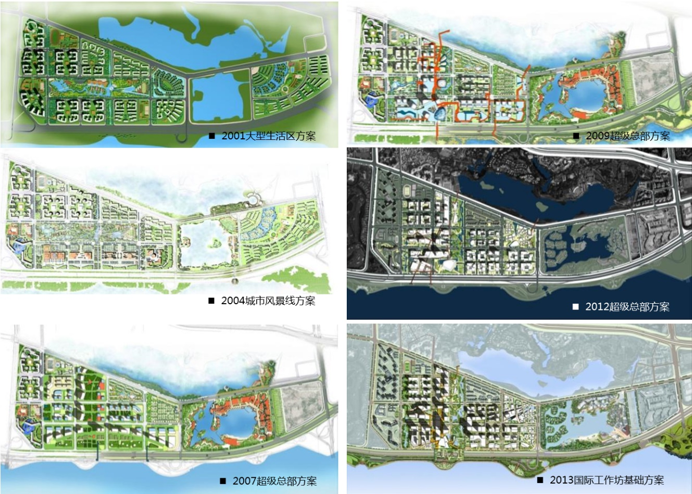
图1规划历程
Fig.1 Course of Planning
2011年，原深圳市规划和国土资源委员会重新启动了对该地区的规划设计研究工作，开展了《深圳湾超级总部基地控制性详细规划》。作为深圳未来城市建设的实验展示性地区，建议将生态低碳城市构想、数字城市技术等新科技综合融入深圳湾填海区，与后海中心区形成良性互动。该规划于2014年3月14日，获深圳市政府五届一百零五次常务会议原则通过。
In 2011, the former Shenzhen Urban Planning, Land and Resources Commission restarted the planning and design of the area and conducted the Regulatory Detailed Plan of Shenzhen Bay Super Headquarters Base. It proposes to incorporate ecological and low-carbon city concept, digital city technology and other new technologies into Shenzhen Bay Reclamation Area, which serves as an experimental demonstration area for future urban development of Shenzhen, for positive interactions with Houhai Central District. The regulatory detailed plan was approved on March 14, 2014 in the 105th session of the 5th Standing Meeting of the Shenzhen Municipal Government.
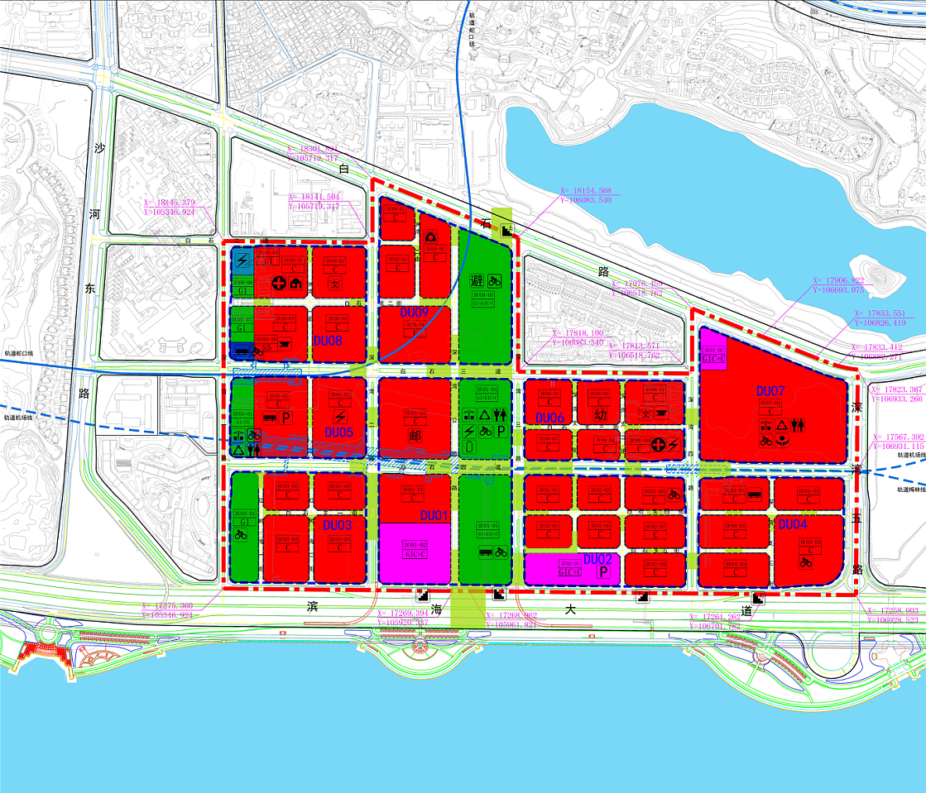
图2深圳湾超级总部基地控制性详细规划2014版
Fig.2 Regulatory Detailed Plan of Shenzhen Bay
Super Headquarters Base （2014）
2013年和2014年，在当时的规划研究成果基础上，原深圳市规划和国土资源委员会开展了深圳湾超级总部基地国际工作坊和超级总部核心区概念方案的国际竞赛，集思广益提出了极富想象力及创造性的未来城市建设概念，也使得本片区的公众关注度及国际知名度进一步提升。2018年，为了对该片区提出更具创意与国际视野的深化、优化设计工作，深超总办公室开展了深圳湾超级总部基地城市设计优化、片区综合交通提升规划与交通详细规划两项国际咨询活动，对片区的布局结构、开发强度、功能构成、公共空间、建筑风貌、生态景观、城市天际线、综合交通、地面道路、地下道路、轨道规划等内容进行系统性设计，指导片区高质高效、科学有序的开发建设和运营管理。
目前，上述两项国际咨询正进行优化整合，计划于6月底形成最终成果。
In 2013 and 2014, based on the existing results of planning and research at that time, the former Shenzhen Urban Planning, Land and Resources Commission organized the Shenzhen Bay Super Headquarters Base International Workshop and an international competition on the conceptual plan of the core area of Shenzhen Bay Super Headquarters Base. These activities helped solicit ideas from all walks of life to refine and detail the design in terms of creativity and international vision. In these activities, imaginative and creative construction concepts of future cities were proposed which helped boost the public attention to and international reputation of this area.In 2018, Open Call for Urban Design Optimization of Shenzhen Bay Super Headquarters Base and Comprehensive Transportation Improvement Planning and Detailed Transportation Planning were hosted by the SSBHO to systematically design of the layout structure, development strength, functional composition, public space, architectural style, ecological landscape, city skyline, integrated transportation, ground-level roads, underground roads, urban railway planning are required to strengthen lean planning control of spatial form and guide orderly development and construction of the area.
At present, the above two international consultations are under optimization and integration, and the achievement plan to reveal by the end of June.
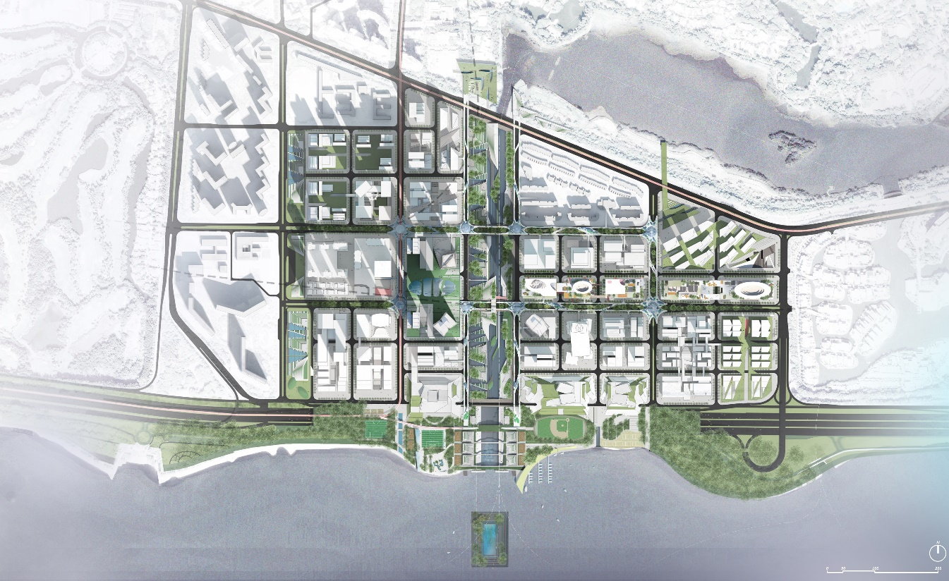
图3深圳湾超级总部基地城市设计优化国际咨询中标方案总平面图
Fig.3 Winning Proposal of International Consultation on Urban Design Optimization of Shenzhen Bay Super Headquarters Base

2.3 现状条件

2.3 Existing Site Conditions
深圳湾超级总部基地位于深圳湾北面，华侨城地区南部，是塘朗山-华侨城-深圳湾城市功能空间轴的核心城市功能区段之一。深圳湾由西至东布局了蛇口地区、西部通道口岸、后海中心区、高新区和华侨城地区。根据最新深圳市城市总体规划，环深圳湾地区将成为粤港澳大湾区最重要的城市地区之一，成为激发深圳跻身全球一流城市的能量起点。
Located in the north of Shenzhen Bay and in the south of OCT, Shenzhen Bay Super Headquarters Base is a core segment of the Tanglang Mountain-OCT-Shenzhen Bay urban functional space axis. Shekou area, West Corridor port, Houhai Central District, High-Tech Zone and OCT area are included in the layout of Shenzhen Bay from the west to the east. According to the latest master plan of Shenzhen, Shenzhen Bay rim will become one of the most crucial urban area in the Guangdong-Hong Kong-Macao Greater Bay Area, and a base powering Shenzhen’s efforts to be a first-tier city in the world.
目前，按照深圳市委市政府的工作部署，深圳湾超级总部基地已进入加速建设实施阶段，除早期联泰返还用地项目、地铁上盖投融资项目（深湾汇云中心）外，近年来已出让了中信证券、招商银行、天音通信、碳云智能、恒力、中国电子、中兴通讯、神州数码、万科、恒大和欧加通信11个项目，已出让土地面积约共41.2公顷，上述用地已占到规划总用地的35%左右。
Currently, according to the work deployment of the Shenzhen Municipal CPC Committee and the Municipal Government, Shenzhen Bay Super Headquarters Base has ushered in a stage of accelerated construction. Besides the early land return project of Liantai Group and the investment and financing project located above the subway station（Shenzhen Bay Huiyun Center）, a total land area of 41.2 hectares has been assigned to eleven projects in recent years, including Citic Securities, China Merchants Bank, Telling Telecommunication, iCarbonX, Hengli Group, China Electronics, ZTE, Digital China, Vanke, Evergrande and Oppo, accounting for 35% of the total planned land use area.
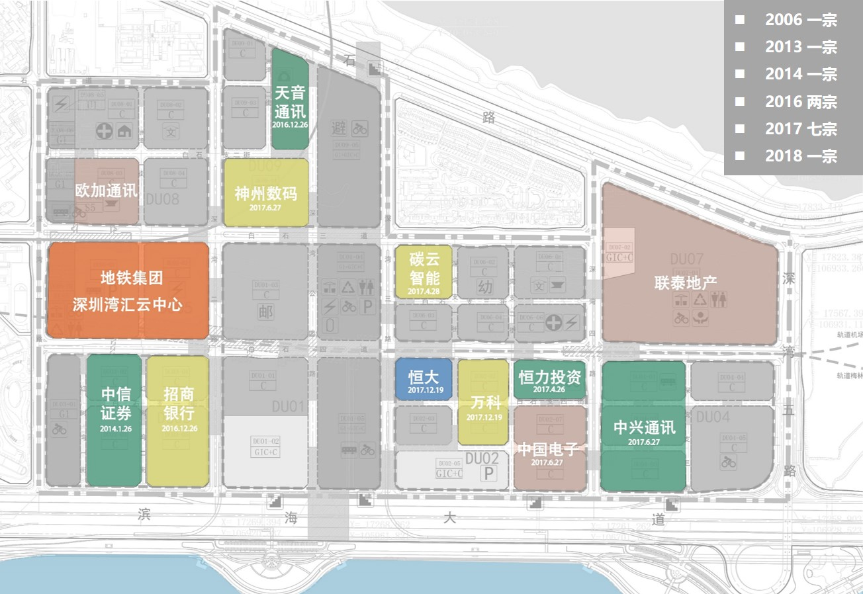
图4土地出让情况图
Fig.4 Current Land Assignment

2.4 工作目标

2.4 Work Objectives
深圳湾超级总部基地片区统筹开发建设与运营国际咨询活动旨在面向世界，面向未来，以构建粤港澳大湾区世界级城市群巅峰之地为发展愿景，通过宏观环境分析，国内外案例对标，清晰定义片区的战略愿景和功能角色；并通过片区文化、商业发展规划、开发运营模式研究、空间布局及运营管理研究、推广宣传研究等，系统设计实施路径，指导片区高质高效、科学有序地开发建设和运营管理。
International Consultation for Overall Planning，Development and Operation of Shenzhen Bay Super Headquarters Base is future-oriented and open for global participation. With a vision of creating a masterpiece of world-class urban cluster in the Guangdong-Hong Kong-Macao Greater Bay Area, it requests participants to distinctively define the strategic goals and functions of the area through macroscopic environment analysis, global cases benchmarking, and to guide the effective and scientific development and operation management of the area through cultural and economic development planning, development and operation patterns research, spatial layout and operation management research, marketing and promotion research, systematic design and construction methods.

2.5 工作范围

2.5 Work Scope
本次国际咨询的核心研究范围为：滨海大道、深湾一路、深湾五路、白石三道、白石路所围合的区域，用地面积117公顷。
The core scope of this international consultation is the area enclosed by Binhai Boulevard, Shenwan 1st Road, Shenwan 5th Road, Baishi 3rd Road and Baishi Road, with a total land area of 117 Hectares.
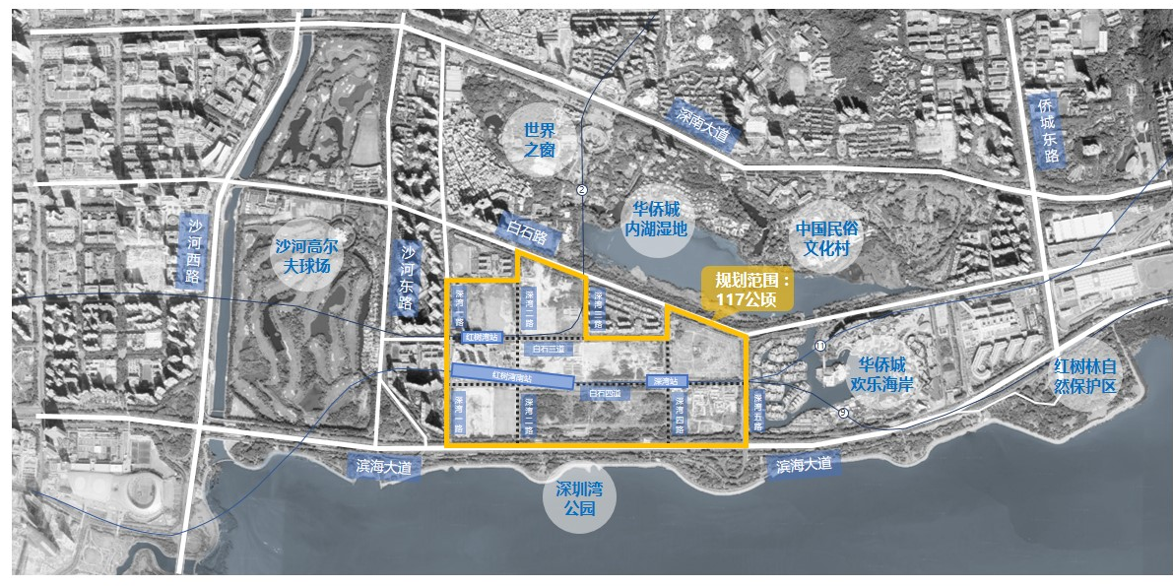
图5本次国际咨询核心研究范围图
Figure 5: The core scope of this international consultation

2.6 工作内容

2.6 Work Contents
本次国际咨询活动，结合目前已出让土地的规划设计情况，与片区其他专项研究团队协同工作，充分对接，提出片区开发建设与运营的综合解决方案。具体工作应包括但不限于以下内容：
The participants of this international consultation should work with other special research teams and propose wholistic and integrated solutions for overall planning, development and operation of this area, based on the current land use and planning design. The final contents should include but not limit to the followings:

2.6.1 宏观环境分析

2.6.1 Macro Environment Analysis
分析全球经济和科创的发展形势及重大机遇，系统研究国家及地方政策，重点关注粤港澳大湾区发展及深圳城市能级跃升的痛点和需求；梳理城市核心区经济，如金融、科创、商务等潜在目标产业上位规划和政策导向，分析发展趋势、发展特点和产业布局等；调研政府相关部门需求、世界500强企业及“独角兽”等创新性企业的发展需求；调研片区内入驻企业的项目定位、发展规划以及对区域协同发展的诉求。
Analysis of global trends and major opportunities of economy, technology and creative industry, systematic research of national and local policies with focuses on Guangdong-Hong Kong-Macao area, understanding Shenzhen’s pain points and needs of urban upgrades; sorting out economy system of urban core area, such as preliminary planning and policy guidance of financial industry, creative and technological industry, business development and other potential industries, analysis of trends, development features and industry distributions; Research on the future needs of related governmental entities, Fortune 500 companies, “Unicorn” enterprises and other creative industries; Research on the project positioning, future planning and needs of perspective incoming enterprises of this area.

2.6.2 国内外案例对标借鉴

2.6.2 Benchmarking Domestic and Global Developments
对标国内外案例，包含但不限于全球能级的城市核心区、金融商务区、高能级湾区等（如金丝雀码头、纽约哈德逊广场、纽约湾区、东京湾以及国内城市核心区等），研究案例的目标定位、产业及城市功能、空间分区、运作模式、载体业态、空间布局、政策环境等。重点借鉴先进的城市发展理念、经济辐射引领效应、城市特质及文化底蕴彰显、国际交往、湾区发展路径、核心区运营管理模式等方面的经验和教训。
Benchmarking domestic and global developments, including but not limiting to world-class urban core district, financial and business centers, high-level bay area development （such as Canary Wharf, New York Hudson Yard Development, New York Bay Area Development, Tokyo Bay Area Development and other domestic urban core area developments）, research on their development objectives and positioning, industry and urban programs, zonings, operation models, business, spatial arrangements, political environment and etc. Research focuses should be given to advanced urban development concepts, leading effects of economical influences, urban features and cultural development, international connections, course of development of bay areas, operation models of core districts and other related experiences.

2.6.3 片区发展战略定位及推广宣传研究

2.6.3 Research on Regional Development Strategies, Positioning and Marketing
综合宏观环境分析，结合对标案例研究，全面梳理片区资源禀赋及优劣势；同时研究深圳其他重点片区及粤港澳大湾区其他城市核心片区发展策略，定义深圳湾超级总部基地与其它片区竞争和协同关系，总结深圳湾超级总部基地的差异化竞争点；清晰定义片区的功能角色，精确解读“巅峰之作”的内在含义及其外延，为片区提出明确战略愿景、定位，设计实施路径。提出国际化推广宣传建议，提升整体项目和城市的国际影响力和全球美誉度。
Based on Macro environmental analysis and benchmarking research, wholistic analysis of regional resources, advantages and disadvantages; research on development strategies of other key districts of Shenzhen and core areas of other cities of Guangdong-Hong Kong-Macao Greater Bay Area, defining competitive and collaborated relationship between Shenzhen Bay Super Headquarters Base and other key districts, stating the competitive differentiation of Shenzhen Bay Super Headquarters Base; Clearly defining the role of each sub-districts, with precise interpretation of the core concept of “masterpiece of world-class urban cluster” and its conceptual extensions, clearly stating the strategic vision, positioning, and design implementations of this area. Propose international marketing strategies in order to increase the global influences and reputation of the project and the city.

2.6.4 片区发展、城市功能、空间布局及运营管理建议

2.6.4 Suggestion on Regional Development, Urban Programs, Spatial Layout and Operations and Managements
基于深圳湾超级总部基地战略定位，为潜在入驻企业和主要服务人群画像，深入了解目标企业及人群需求；研究未来重点发展产业和导入的城市功能及公共文化设施配套；与城市设计优化、片区综合交通提升规划与交通详细规划、智慧城市研究、地下空间规划、市政工程规划、中央绿轴景观规划等专项研究团队协同工作，落实产业和城市功能的空间落位、不同功能业态配比等；研究地上地下运营管理界面划分，提出所需导入资源建议和运营管理建议。
User profiling of prospective enterprise tenants based on strategic positioning of Shenzhen Bay Super Headquarters Base and in-depth research of demands from targeted enterprise and users; research on future key development industries, anchored urban programs and public cultural facilities; Collaborating with research team on urban design optimization, comprehensive regional transportation improvement planning and detailed transportation planning, smart cities study, underground space planning, municipal projects planning, central green axis landscape planning, finalizing spatial placement of industries and urban programs, composition ratio of different business formats; Research on aboveground and underground operation and management interface, propose necessary resources and suggestion on operations and managements.

2.6.5 中央绿轴、地标地块及地上地下公共区域专项研究

2.6.5 Special Research on Central Green Axis, Landmark Plot and Public Space in Both Aboveground and Underground
重点分析中央绿轴、地标地块及地上地下公共区域的功能业态，提出文化主题塑造建议；研究中央绿轴等公共区域与周边项目的协同关系，提出开发运营方案建议，充分发挥其区域带动作用和辐射作用；提供公共空间产权政策建议；提出公共区域及24小时街区的实施范围及运营管理建议。
Key analysis on central green axis, landmark plot and public space in both aboveground and underground, with suggestions on shaping cultural features; Research on synergistic relationship between public space, such as the central green axis, and other areas of the project, giving suggestions on development and operation schemes which can optimize its regional influences and regional driven role; Advising on property rights policy on public space; Advising on implementation scope and operations of public area and 24-hr neighborhood.

2.6.6 片区文化、商业发展规划

2.6.6 Planning on Regional Cultural and Business Development
从片区周边范围、南山区、深圳市乃至粤港澳大湾区整体发展趋势及现状进行分析，统筹考虑本片区的文化、商业布局及运营策略，实现片区内产品类型多元化，形成集聚优势，避免同质化竞争。从片区公共配套服务功能考虑，确定片区文化、商业整体功能定位，包括辐射范畴、服务对象、业态需求、与其他功能区的互补关系；根据服务对象、人流来源，提出布局建议及招商策略。针对片区公共文化建筑提出项目类别、建设规模、运营策略等分析建议；针对已出让及未出让地块项目，提出其文化及商业建设指标的功能、类别、业态、运营管理等建议，作为单个项目相关设计、审批的参考依据。
Analysis of the overall development trend and existing conditions from the surroundings of the consulting area, Nanshan District, Shenzhen City, and Guangdong-Hong Kong-Macao Greater Bay Area, Overall consideration of operational strategies for culture and business distributions, diversifying product types in the region, forming agglomeration advantages and avoiding homogenization competitions. From the perspective of the public supporting programs, positioning cultural and commercial program for this area, including its effective range, service targets, business requirements, and complementary relationship with other programs and areas; Providing strategies on business layout and leasing. Based on assigned and unassigned land plots, advising on construction volume quotas related to function, category, business, operation management and etc. of cultural and commercial programs for relevant design and approval reference of each individual design scheme.

2.6.7 片区开发运营实施策略

2.6.7 Implementation Strategies on Regional Development and Operations
开发模式研究，通过研究与本片区相类似的国际、国内现有案例开发建设模式，提出政府、市投控公司及入驻企业等在片区统筹开发建设中的角色分工和协作机制。运营管理策略，设计多种“1+N”国际化的片区运营平台搭建方案，并进行对比分析；结合功能定位、配套服务、招商营运等方面提出片区的运营管理策略，包括但不限于招商服务、营商环境、城市服务等。机制创新研究，如土地出让遴选方案和相关标准、多方资源合作机制创新、招商服务政策创新、规划执行落地保障机制创新等。开发时序策略，梳理片区统筹建设内容，提出片区土地出让、开发时序等策略建议，保证公共系统建设（如地下空间、道路、市政等）与单个地块建设有效衔接，并编制片区十年发展纲要。
Development Models Research: Based on case study of development mode of similar global and domestic developments, propose role divisions and collaboration mechanisms between government entity, Shenzhen Investment Holdings Co., Ltd. and prospective enterprise tenants in this regional development. Operation and Management Strategies: Design and compare multiple “1+N” global platform construction solutions on regional operations; Propose strategies on regional operations and managements in program positionings, supporting services and leasing and operations, including but not limiting to leasing services, business environment, city services etc. Mechanism Innovation Research: Includes but not limits to land transfer selection plan and related standards, innovation on collaboration mechanism between multiple contributors, innovation on investment service policy, innovation on planning implementation mechanism etc. Development Sequence Strategies: sort out overall development contents of this region, advise on land assignment and development sequence and strategy, ensure smooth transition between infrastructure construction （underground space, roadworks and municipal projects） and individual plots, and prepare 10-year development plan for the region.

2.6.8 片区财务测算

2.6.8 Financial Projection of Regional Development
建立产业经济测算模型，预测整个片区的产值、税收、就业、科研等不同维度的产出情况，测算片区整体的产业经济效益和社会效益;根据项目综合开发方案，建立基础设施、公共配套及核心项目财务测算模型，对项目开发的经济成本和预期收益进行测算，分析政府和开发企业的经济成本和收益情况。
Establish financial model for industrial economy, forecasting financial output from production, taxation, employment, research etc., measure the industrial economic benefits and social benefits of the area; establish financial projection models for infrastructure development, public services and core development projects, cost-benefit analysis for project developments, and cost-benefit analysis for government and developer.

编制依据

Basis for Consultation
《深圳湾超级总部基地片区统筹开发建设与运营国际咨询-工作规则》；
International Consultation for Overall Planning，Development and Operation of Shenzhen Bay Super Headquarters Base – Work Rules;
《深圳湾超级总部基地片区统筹开发建设与运营国际咨询-咨询要求》；
International Consultation for Overall Planning，Development and Operation of Shenzhen Bay Super Headquarters Base – Consultation Requirements;
《深圳湾超级总部基地片区统筹开发建设与运营国际咨询-技术任务书》（入围后发出）；
International Consultation for Overall Planning，Development and Operation of Shenzhen Bay Super Headquarters Base – Technical Assignment Book（Issued after the finalist）；
主办单位提供的相关材料；
Relevant plans and basic materials provided by the Organizer;
国家、省市、地区现行的有关法律法规、规章、规范性文件、政策文件及上层规划等。
Relevant laws, regulations, rules, normative documents, policy documents and overall planning of the state, provinces, and regions.

工作安排

Work Arrangements
本次国际咨询包括资格预审、提案评审、审议定标、咨询服务四阶段。
This international consultation includes four phases, namely prequalification, proposal evaluation, proposal consolidation and consultation services.

第一阶段：资格预审（计划2019年6-7月）

Phase 1: Prequalification （Plan in June-July, 2019）
6月下旬发布国际咨询正式公告，在全球范围内公开征集咨询单位参与，鼓励境内、外咨询单位报名并提交相应业绩、国内分支机构证明文件（如有）、资质（如有）、团队成员构成、履历以及项目经验等相关资料，7月中旬组建资格预审委员会，经资格预审委员会择优票决选取5家入围咨询单位，公示资格预审入围名单，发放入围通知书及技术任务书，参与下一阶段的提案编制。（注：若通过资格预审的入围咨询单位不足5家，主办单位将重新发布公告、组织国际咨询。入围咨询单位请提前登录深圳市工程交易服务中心http://zjj.sz.gov.cn/jsjy/咨询办理企业信息登记和数字证书，如为联合体投标，联合体各成员均需办理，具体办理流程及所需时间等详情以咨询深圳市建设工程服务中心信息为准）
Official announcement of international consultation is released in late June and open to domestic and international consulting firms to submit relevant information such as performance, domestic branch certification documents （if any）, qualification certificate （if any）, team member composition, resume and project experience and other relevant materials. Prequalification meeting will be arranged in middle July, and the prequalification committee will shortlist 5 firms from ballot. The result will be announced and official notices of shortlist and Technical Assignment Book will be sent to participated firms to proceed with the proposal preparation in the next phase.（Note: if the number of the consulting firms passed pre-qualification is less than 5, the sponsor will re-release the announcement and organize international consultation. The 5 shortlisted consulting firms shall log in Shenzhen Engineering Transaction Service Center http://zjj.sz.gov.cn/jsjy/ for enterprise information registration and digital certificates in advance. For joint bidding, all members of the consortium shall go through the registration and digital certificates. consulting firms could refer to Shenzhen Construction Engineering Service Center for details of the procedures and time required.）

第二阶段：提案评审（计划2019年7-8月）

Phase 2: Proposal Evaluation （Plan in July-August, 2019）
5家入围咨询单位在规定时间内根据技术任务书完成并提交提案编制成果。计划8月中旬举行提案评审会。由提案评审委员会对5家入围咨询单位提交的提案编制成果及现场汇报情况进行评审，确定3家不排序优胜提案单位，并在深圳市建设工程交易服务网公示。
The 5 Short-listed consulting firms are required to finish and submit the proposal submissions according to Technical Assignment Book within the specified timeframe. Proposal evaluation meeting is planned to be held in middle August. The proposal evaluation committee will evaluate all the proposals and presentations given by the 5 short-listed firms and select 3 non-ranking winning proposals. The result will be announced on the website of Shenzhen Construction Project Trading Service Network.

第三阶段：审议定标（计划2019年8-9月）

Phase 3: Proposal Consolidation （Plan in August– September, 2019）
审议定标，3家不排序优胜提案单位报深超总指挥部审议，按深超总指挥部要求依照有关程序定标确定第一名中标单位，并在深圳市建设工程交易服务网公示。
In the proposal consolidation, the Shenzhen Bay Super Base Construction Headquarters will evaluate all 3 non-ranking winning proposals, and choose the first bid-winning firm according to the relevant procedures and requirements，and the result will be announced on the website of Shenzhen Construction Project Trading Service Network.

第四阶段：咨询服务（定标后4个月内完成，计划2019年9月-2021年1月）

Phase 4: Consultation Services （completed within 4 months after the proposal consolidation, Plan in September, 2019 – January, 2021）
由第一名中标单位完成本项国际咨询的全部工作内容，工作过程中需配合参与沟通协调会议及进行阶段成果汇报等。
The first bid-winning firms will complete all the consulting work contents of this project, meanwhile participate in the communication & coordination meeting and give needful research output reports to Shenzhen Bay Super Base Construction Headquarters during work process.
中标单位在完成经深超总指挥部审定的专题报告后持续提供必要的专业服务，服务期限至完成专题报告后满一年，其中包含参加主办单位或承办单位组织的包含但不限于工作坊、专家研讨会、沟通协调会等，次数不多于六次。
Bid-winning firms are expected to continuously provide necessary professional services after the completion of the special report approved by the Shenzhen Bay Super Base Construction Headquarter. Professional services are expected within one year after the conclusion of consultations, participation of, including but is not limited to, workshops, expert seminars, communication and coordination meetings organized by Organizer or Co-organizer no more than 6 times.
中标单位在服务期间应配合主办单位、承办单位与本成果有关的宣传工作，如及时提供相关宣传文案资料等。
The bid-winning firm shall cooperate with the marketing of the organizer and co-organizer related to the results during the service period, such as providing relevant marketing strategies in a timely manner.

报名要求及方式

Registration Requirements and Method

5.1 报名要求

5.1 Registration Requirements
（1）资格要求：本次咨询活动不设资质要求，国内外咨询单位均可报名参加，不接受个人名义报名。国内外报名单位应具备有效机构注册文件。
（1）Qualification Requirements: This Open Call is open to all international and local consulting firms. Registration in name of individual or group comprising individuals is not accepted. International and local applicants should have valid registration documents.
（2）经验及其他要求：具有相关咨询服务经验，鼓励具有国际知名城市、国内一线及重点城市核心区相关咨询服务经验的单位报名（证明材料不限于盖章合同封面、盖章中标通知书等，提供复印件，原件备查）。咨询服务的专题报告编制工作阶段，要求提供不少于二人驻场服务。（提交报名文件即视同接受驻场服务要求，驻场费用含在咨询服务报价内）
（2）Experience and other requirements: Consulting firms with relevant services experience, especially with international famous cities or domestic big/main cities core area relevant consulting services experience， are encouraged to sign up （The certification materials are not limited to the cover of the seal contract, sealed notice of winning etc., submission requires copied version and the original files are subjected for future reference.） No less than two people are required to provide stay-on-site service during the work stages of special report establishment for the consulting service. （The submission of the registration document is deemed to be subject to the acceptance of the resident service request, and the resident fee is included in the consultation service quotation）
（3）联合体的要求：本次咨询活动接受联合体报名，联合体家数不超过3家，但需以联合体协议书明确联合体的牵头单位和各自职责。组成项目联合体的各成员单位不得再以自己的名义单独参与投标，也不得同时加入本项目其它联合体参与投标。
（3）Requirements on consortiums: This Open Call is open to consortiums, each consortium must not include more than 3 firms, and must use‘Consortium Agreement’ to specify the leading party and respective responsibilities. In case of joint participation, each party in the joint group cannot take part in this competition independently in its own name, or involve in any other joint groups with other design firms.

5.2 报名方式

5.2 Registration Method
（1）电子邮件报名：报名的咨询单位应在北京时间2019年7月8日17:00前，以电子邮件形式向国际咨询组织服务单位发送电子版报名材料（电子邮件名请标注：深圳湾超级总部基地片区统筹开发建设与运营国际咨询报名文件-咨询单位名称），完成网上报名。
（1）Registration by Email: The interested consulting firms should complete the online registration by emailing the registration documents, with email subject line stating “Registration Documents for International Consultation for Overall Planning，Development and Operation of Shenzhen Bay Super Headquarters Base – name of consulting firm”. The documents must be sent to the Organization Consulting Support before 17:00 July. 8, 2019 （Beijing Time）.
（2）纸质报名文件提交：报名的咨询单位应于北京时间2019年7月11日17:00前，将完整的纸质报名文件送至深圳市福田区振华路8号设计大厦2楼深圳市建设工程交易服务中心业务办理窗口，并在外包封上标注“深圳湾超级总部基地片区统筹开发建设与运营国际咨询报名文件-咨询单位名称”。
（2）Submitting Paper Registration Materials: The registered consulting firms should send a full set of registration materials to Service windows of Shenzhen Construction Project Transaction Service Center, F2, Design Building, 8, Zhen Hua Lu, Futian District, Shenzhen, China before 17:00 July. 11, 2019 （Beijing Time）. The envelop should be indicated with “Registration Documents for International Consultation for Overall Planning，Development and Operation of Shenzhen Bay Super Headquarters Base – name of consulting firm”.

日程安排

Schedule
深圳湾超级总部基地片区统筹开发建设与运营国际咨询日程安排表
International Consultation for Overall Planning，Development and Operation of Shenzhen Bay Super Headquarters Base Time Schedule
阶段  Phase | 时间  Deadline | 事项  Activities
第一阶段  资格预审  Phase 1  Pre-qualification | 2019年6月26日（周三）  June 26 2019 （Wed） | 发布正式公告、咨询要求和工作规则  Release of official announcement and Consultation Brief
第一阶段  资格预审  Phase 1  Pre-qualification | 2019年7月8日（周一）  July 8 2019 （Mon） | 提交电子报名资料  Deadline for submitting electronic registration materials
第一阶段  资格预审  Phase 1  Pre-qualification | 2019年7月11日（周四）  July 11 2019 （Thu） | 提交纸质报名资料，报名截止（本次咨询以收到纸质报材料为准）  Submission of paper registration materials （the effectiveness of registration is subject to the receipt of the paper documents）
第一阶段  资格预审  Phase 1  Pre-qualification | 2019年7月15日（周一）  July 15 2019 （Mon） | 由资格预审委员会对报名材料进行资格预审，从中筛选出5家入围咨询单位。  Assessment of the registration materials by the Pre-qualification Committee to shortlist 5 consulting firms to proceed with the subsequent phase.
第一阶段  资格预审  Phase 1  Pre-qualification | 2019年7月16日（周二）  July 16 2019 （Tue） | 公布资格审查结果，发出入围通知书及技术任务书  Announcement of pre-qualification results and distribution of Shortlist Notice and Technical Assignment Book
第二阶段  提案评审  Phase 2  Proposal Evaluation | 2019年7月23日（周二）  July 23 2019 （Tue） | 书面提交质疑问题截止时间  Deadline for submitting questions in written form
第二阶段  提案评审  Phase 2  Proposal Evaluation | 2019年8月12日（周一）  August 12 2019 （Mon） | 提交提案编制成果  Submission of proposal preparation deliverables
第二阶段  提案评审  Phase 2  Proposal Evaluation | 2019年8月15日（周四）  August 15 2019 （Thu） | 召开提案评审会，择优票决选出3家不排序优胜提案单位  Proposal evaluation meeting, choose 3 non-ranking winning firms
第二阶段  提案评审  Phase 2  Proposal Evaluation | 2019年8月16日（周五）  August 16 2019 （Fri） | 提案评审结果公布  Announcement of evaluation results
第三阶段  审议定标  Phase 3  Proposal Consolidation | 2019年8月下旬  Late August 2019 | 召开定标会，确定第一名中标单位  Proposal consolidation meeting and finalize first place, bid-winning firms
第三阶段  审议定标  Phase 3  Proposal Consolidation | 2019年9月上旬  Early September 2019 | 发布最终评审结果  Announcement of the final evaluation results
第四阶段  咨询服务  Phase 4  Consulting Service | 2019年9月-2021年1月  Sep. 2019 - Jan. 2021 | 完成本次国际咨询的所有专题报告以及后续服务全部工作内容  Completeness of all special reports of this open call and all the work contents afterwards
注：上表均为北京时间，主办单位保留调整日程安排的权利。
Note: Time stated above is Beijing Time and host reserves the rights to adjust the schedule.

成果要求

Submission Requirements

7.1 第一阶段资格预审报名文件要求

7.1 Requirements on the prequalification registration documents at Phase 1

7.1.1 资格预审报名文件提交规格与数量

7.1.1 Specifications and quantities of registration documents at prequalification phase
（1）资格预审报名文件（明标）：A4规格（210mm×297mm），1正7副，双面打印，简装，软皮封面装订成册，并附目录，内容请按以下顺序进行编辑：
（1）Prequalification Registration documents （open bid） in A4 （210mm×297mm） shall be made into 1 original and 7 duplicates. Printing on both sides and simple binding are required. The documents will be bound into volumes with soft front cover and include the table of contents. The contents should be provided in the following order:
- 报名表（详见附件1）；
- Registration Form （see Appendix 1 for details）;
- 联合体协议书（详见附件2）；
- Agreement of Consulting Consortium （see Appendix 2 for details）;
- 咨询单位法定代表人身份证明文件复印件；
- ID photocopy of the consulting firm’s legal representative
- 法定代表人授权书及被授权人身份证明文件复印件（详见附件3，该授权人代表咨询单位在国际咨询过程中签署相关文件）；
- Legal Representative’s Power of Attorney, the authorized representative’s identification （see Appendix 3 for details; such authorized representative shall sign the relevant documents on behalf of the consulting firm during the Open Call process）;
- 营业执照或有效单位注册文件复印件；
- Photocopies of Business License or effective business registration documents;
- 单位简介（格式自定）；
- Company profile （self-determined format）;
- 国内分支机构证明文件（如有）；
- Domestic branch certification documents （if any）
- 资质（如有）；
- Qualification certificate （if any）
- 咨询团队（请按以下表格填写参与本次国际咨询团队成员，此表中仅填写参与本项目的最主要咨询成员，个人简历格式自定，包含但不限于：姓名、性别、年龄、教育背景、执业资格、专业成就、项目经验、获得奖项）
- Consulting team （please fill in the participating team members based on the following tables; please only fill in the main consulting personnel proposed for the Project; the CV format is subject to the consulting firm's discretion, including but not limited to the name, gender, age, education background, practice qualification, professional achievements, honors and awards）
单位名称  Organization Name | 拟担任职务  Proposed Position in the Project | 姓名  Name | 专业  Specialty | 备注  Remarks | ……
项目负责人
Project Leader
 | ... …
- 业绩证明（请按以下表格提供单位和项目负责人相关咨询服务经验的代表业绩，不超过8个项目，具有国际知名城市、国内一线及重点城市核心区相关咨询服务经验优先，近五年业绩优先,证明材料不限于盖章合同封面、盖章中标通知书等，提供复印件，原件备查。）；
- Project portfolio （please provide the representative similar projects （no more than 8） of the consulting firm or the project leader, with the format to be determined by the consulting firm）

单位名称  Organization Name | 业绩代表  Project portfolios | 项目名称  Project Name | 项目地点  Project Location | 项目签订日期  Project Signing Date | 项目内容  Project Contents | 项目完成情况  Project Status | 项目负责人  Main Personnel | 证明材料  Proof Materials
□咨询单位业绩
□Project portfolios of the consulting firm
□项目负责人业绩
□Project portfolios of the project leader
- 咨询单位认为有帮助的其他资料。
- Other information deemed useful by the consulting firms.
注：咨询单位须保证在各阶段主要团队成员构成保持一致；若主要团队成员发生变动，须得到主办单位或承办单位的同意方可更换。更换后的团队成员须具有不低于原团队被替换成员的相关项目经验和资历。项目负责人原则上不允许变更。
Note: The consulting firm must ensure that the composition of the main team members is consistent at all stages; if the main team members change, they must be approved by the organizer or the co-organizer before they can be replaced. The replaced team member must have relevant project experience and qualifications that are not lower than the original member. The project leader is not allowed to change in principle.
（2）电子文件：以电子邮件及光盘形式提交，光盘一份，电子邮件于2019年7月8日17:00前发送到组织咨询服务单位邮箱sztc@sztc.com，邮件名请标注“深圳湾超级总部基地片区统筹开发建设与运营国际咨询报名文件-咨询单位名称”，光盘文件随纸质文件一起提交，报名文件为word或者可编辑的PDF格式，盖章页面（如报名表、联合体协议书、法定代表人授权书等）需扫描。
（2）Electronic files will be submitted both by email and in CD. One copy of CD is required. The email should be sent to the Organization Consulting Support’s email box: sztc@sztc.com by 17:00 of July 8, 2019 with the subject line stating “Registration Documents for International Consultation for Overall Planning，Development and Operation of Shenzhen Bay Super Headquarters Base – Consulting Firm’s Name”. CD and paper documents will be submitted as a whole package. The registration documents should be in the format of Word or editable PDF, with the stamped pages （such as Registration Form, Agreement of Consulting Consortium, and Legal Representative’s Power of Attorney） to be scanned.

7.1.2 资格预审报名文件递交方式

7.1.2 Submission of documents in the prequalification phase
第一阶段纸质报名文件需按要求在截止时间递交到深圳市福田区振华路8号设计大厦2楼深圳市建设工程交易服务中心业务办理窗口，如在截止时间以后收到的相关文件，将拒绝接收。递交方式可自行选择现场递交和邮寄递交。采用邮寄递交方式的，咨询单位须自行对邮寄途中的安全性、保密性和时效性负责，递交截止时间前未寄到的报名文件将被拒绝接收。
The paper registration documents in the first phase should be submitted to Service windows of Shenzhen Construction Project Transaction Service Center, F2, Design Building, 8, Zhen Hua Lu, Futian District, Shenzhen, China by the deadline as per the relevant requirements, otherwise they will be rejected. Registration firms can choose either delivery service or delivery in person. Should registration firms choose delivery service, it is the firms’ sole responsibility to ensure registration documents’ security, confidentiality and delivery on time. Any registration documents delivered after the deadline will be rejected.
递交截止时间：2019年7月11日17:00（北京时间，以业务办理窗口收到纸质报名文件时间为准）。
Submission Deadline: 17:00 July 11, 2019 （Beijing Time, subject to the time when the Service windows receives the paper registration documents）.
递交邮箱：sztc@sztc.com
Submission Email: sztc@sztc.com
递交地址：深圳市福田区振华路8号设计大厦2楼深圳市建设工程交易服务中心业务办理窗口
Submission Address: Service windows of Shenzhen Construction Project Transaction Service Center, F2, Design Building, 8, Zhen Hua Lu, Futian District, Shenzhen, China
联系人：史先生 （+86 15099910515）
Contact: Mr. Shi （+86 15099910515）

7.1.3 资格预审报名文件要求

7.1.3 Requirements on the registration documents in the prequalification phase
（1）报名文件正本及副本必须符合以下要求：正本文件需签字盖章的地方请加盖公章及签字，接受电子章及签章，副本可彩印正本。
（1）The original and duplicates of the registration documents must meet the following requirements: the original version shall be duly stamped and signed on required pages. The electronic stamps and signatures are acceptable, and the colored photocopies of the original version may be taken as duplicates.
（2）报名文件外包封上需标注“深圳湾超级总部基地片区统筹开发建设与运营国际咨询报名文件-咨询单位名称”。
（2）The envelope of the registration documents should be indicated with “Registration Documents for International Consultation for Overall Planning，Development and Operation of Shenzhen Bay Super Headquarters Base – Consulting Firm’s Name”.

7.1.4 资格预审评审参考标准（包含但不限于以下要点：仅作评审参考，具体评判标准由资格预审委员会确定）

7.1.4 Reference standard for pre-qualification evaluation （including but not limited to the following points: only for review and reference, the specific evaluation criteria will be determined by the prequalification committee）
（1）报名咨询单位具有类似片区的相关咨询服务经验。
（2）The registered consulting firms has relevant consulting service experience in similar areas.
（2）报名咨询单位具有国际知名城市、国内一线及重点城市核心区的统筹开发建设与运营咨询服务经验。
(2）The registered consulting firms has experience in overall planning, development and operation consulting services in internationally renowned cities, domestic first-line and key urban core areas.
（3）报名咨询单位指派的项目负责人具有类似片区统筹开发建设与运营咨询服务经验。
（3）The project leader assigned by the registered consulting firms should have similar experience in planning, development, construction and operation consulting services.
（4）主要团队成员具有类似片区统筹开发建设与运营咨询服务经验。
（4）The main team members should have similar experience in planning, development, construction and operation consulting services.
（5）主要团队成员专业构成的合理性。
（5）Rationality of the main team members’ majors composition.

7.2 第二阶段提案编制成果

7.2 Requirements on the deliverables in phase 2 propsal evaluation

7.2.1 成果构成

7.2.1 Project Submissions

（1）提案编制成果（明标）

（1）Project proposal（open bid）
根据粤港澳大湾区发展规划、深圳市功能定位和发展形势，结合深圳湾超级总部基地实际情况，以及本次国际咨询工作内容要求，提案编制成果应包括但不限于以下方面（格式自定）：
According to the development plan of the Guangdong-Hong Kong-Macao Greater Bay Area, the functional orientation and development situation of Shenzhen, the actual situation of Shenzhen Bay Super Headquarters Base and the work Contents of this international consultation, the results of the project proposal should include but not limit to the following contents （the format to be determined by the consulting firm）:
- 对项目的理解；
1）Understanding of the Project;
2）对工作任务及工作目标的理解；
- Understanding of the work tasks and objectives;
3）工作方案；
3）Work proposal;
4）团队服务能力；
4）Team performance;
5）进度计划；
5）Proposal schedule;
6）服务承诺；
6）Service Commitment;
7）投标人认为对投标有利的其他资料。
7）Other materials deemed useful by the bidder.

（2）咨询服务报价

（2）Consulting Service Quotation
注：本次咨询服务报价不得超过800万元人民币的上限，否则视为无效报价。
Note：The quotation of this consulting service should not exceed 8 million RMB. Quotation exceeds this number will be voided.
项目名称：深圳湾超级总部基地片区统筹开发建设与运营国际咨询
Project Name: International Consultation for Overall Planning，Development and Operation of Shenzhen Bay Super Headquarters Base
序号  No. | 内容  Contents | 咨询服务报价（人民币：万元）  Consulting service quotation（CNY: in ten-thousand Yuan） | 备注  Note
1 | 深圳湾超级总部基地片区统筹开发建设与运营咨询服务  Consulting service Overall Planning，Development and Operation of Shenzhen Bay Super Headquarters Base | 小写：  In number:  大写：  In text:
说明：
Instructions:
1.最终获得第一名的中标单位，其报价即为深圳湾超级总部基地片区统筹开发建设与运营国际咨询的服务合同价。
1.The quotation of the bid-winning firms will be the contract price of International Consultation for Overall Planning，Development and Operation of Shenzhen Bay Super Headquarters Base.
2.咨询服务报价作为评审依据之一，本项目不承诺最低价中标。
2. Quotation is one of the basis for evaluation, and this project does not promise the lowest price bid is the winning bid.
3.咨询服务报价大小写数字不一致的，以大写数字为准
3.If there is inconsistence between quotation in number and quotation in text, the quotation in text shall prevail.

（3）汇报材料

（3） Presentation Materials
PPT或其他格式，汇报时间控制在20分钟内（含多媒体播放时间）
In PPT or other format, with a reporting time within 20 minutes （including multimedia play time）

7.2.2 提案编制成果提交规格与数量

7.2.2 Requirements on Submission Formats and Quantities of Proposal Submissions
（1）提案编制成果：A4规格（210mm×297mm），1正9副，双面打印，简装，软皮封面装订成册，并附目录。
（1）Project Service Proposal: A4 （210mm×297mm） , 1 original and 9 duplicates. Printing on both sides and simple binding are required. The documents will be bound into volumes with soft front cover and include the table of contents.
（2）咨询服务报价：A4规格（210mm×297mm），1份，单独密封，随提案编制成果一起提交。
（2）Consulting service quotation: A4（210mm ×297mm）, 1 copy, sealed separately and submitted with the project service proposal.
（3）电子文件：U盘及光盘各提交一份，含提案编制成果电子版（PPT、doc文件或可编辑的PDF文件）、咨询服务报价电子版（不可编辑的图片文件或PDF文件）、多媒体演示系统（MP4、AVI或WMV格式），现场汇报演示文件（PPT或其他）等，随提案编制成果一起提交。
（3）Electronic files：one copy of USB and CD-ROM respectively, including proposal of project service proposal in electronic form （ PPT, doc file or editable PDF file）, consulting service quotation in electronic form （uneditable picture files or PDF file）, multimedia presentation system （in MP4, AVI or WMV formats）, on-site presentation files （in PPT or PDF format） and etc., submitted with the project service proposal.

7.2.3提案编制成果递交方式

7.2.3 Submission Method of Proposal Documents
提案编制成果需按要求在截止时间递交到深圳市福田区振华路8号设计大厦2楼深圳市建设工程交易服务中心业务办理窗口，如在截止时间以后收到的相关文件，将拒绝接收。递交方式可自行选择现场递交和邮寄递交。采用邮寄递交方式的，咨询单位须自行对邮寄途中的安全性、保密性和时效性负责，递交截止时间前未寄到的文件将被拒绝接收。
The of proposal documents should be submitted to Service windows of Shenzhen Construction Project Transaction Service Center, F2, Design Building, 8, Zhen Hua Lu, Futian District, Shenzhen, China by the deadline as per the relevant requirements, otherwise they will be rejected. Registration firms can choose either delivery service or delivery in person. Should registration firms choose delivery service, it is the firms’ sole responsibility to ensure registration documents’ security, confidentiality and delivery on time. Any registration documents delivered after the deadline will be rejected.
递交截止时间：2019年8月12日17:00（北京时间，以业务办理窗口收到全部提案编制成果时间为准）。
Submission Deadline: 17:00 August 12, 2019 （Beijing Time, subject to the time when the Service windows receives the paper registration documents）.
递交地址：深圳市福田区振华路8号设计大厦2楼深圳市建设工程交易服务中心业务办理窗口
Submission Address: Service windows of Shenzhen Construction Project Transaction Service Center, F2, Design Building, 8, Zhen Hua Lu, Futian District, Shenzhen, China
联系人：史先生 （+86 15099910515）
Contact: Mr. Shi （+86 15099910515）

7.2.4 提案编制成果提交要求（提案编制成果有下列情形之一的，其提案编制成果将不予受理，由主办单位、承办单位在开标阶段予以判定）

7.2.4 Requirements for submission of the proposal documents （if the proposal documents are in any of the following circumstances, the proposal documents will not be accepted and will be determined by the organizer and co-organizer at the bidding stage）
（1）提案编制成果必须符合以下要求：正本的封底右下角须标明咨询单位名称，由项目负责人签章、咨询单位盖章。
（1）The proposal documents must meet the following requirements: the name of the consulting firm should be marked in the bottom right corner of the cover of the original copy, signed by the project leader and sealed by the consulting firm.
（2）所有提案编制成果必须按时一次交齐，并由组织服务单位签收。
（2）All proposals must be submitted at once and signed by the organization support.
（3）所有提案编制成果须在规定截止时间前送至主办单位指定地点。
（3） All the proposal documents shall be sent to the designated place of the organizer before the prescribed deadline.
（4）每家咨询单位只允许提交单一提案编制成果。
（4）Each consultant can submit only one proposal.
（5）提案编制成果内容表达必须做到完整、清晰、准确。
（5）The content of the proposal must be complete, clear and accurate.
（6）提案编制成果提交后，不得更改提案编制成果的内容。
（6）No change can be made after the submission of the proposals.
（7）所有提案编制成果内容文字可采用中英双语，但中英文内容如有出入以中文为准。
（7）All proposal documents can be written in both Chinese and English, but if there are any discrepancies between Chinese and English, the Chinese version shall prevail.

7.2.5提案编制成果评审标准（包含但不限于以下要点，仅作评审参考，具体评判标准由提案评审委员会确定）

7.2.5 Criteria for evaluating the proposal （including but is not limited to the following points, for reference only, specific criteria to be determined by the proposal review committee）
（1）对本项目规划背景理解是否深刻；对本项目相关的规划及政策解读是否到位；对本项目周边城市及相关区域的现状分析是否精准、合理。
（1）Deep understanding of the background of the project planning; whether the relevant planning and policy interpretation of the project is accurate; whether the existing condition analysis of the surrounding cities and related areas of the project is accurate and reasonable.
（2）对工作任务的理解是否到位，对工作目标的解读是否清晰。
（2）Whether the understanding of tasks is accurate and whether the interpretation of work objectives is clear.
（3）针对本次国际咨询在片区定位、产业发展、运营策略、收益平衡等方面计划采取的工作方案是否具有可操作性、合理性、系统性等。
（3）Whether the proposal prepared for this international consultation is operable, reasonable and systematic in terms of location, industrial development, operating strategy and profitable balance.
（4）项目团队人员安排、进度计划、服务承诺以及保障措施等是否合理到位，报价是否满足本次国际咨询要求。
（4）Whether the personnel arrangement, schedule, service commitment and safeguard measures of the project team are appropriate, and whether the quotation meets the requirements of the international consultation.
（5）是否提出其他能促进本次工作获得更好成果的措施。
（5） Whether it has proposed some other measures that can lead to better results of this project.

7.3第三阶段咨询服务阶段成果

7.3 Deliverables Requirements in Phase 3 Consulting Service Phase

7.3.1 本次国际咨询第一名中标单位最终完成的成果文件包含但不限于以下报告：

7.3.1 The Achievements of the bid-winning firm in this International Consultation should include but are not limited to the following contents:
总报告：《深圳湾超级总部基地片区统筹开发建设与运营专题报告》（PPT版本及word版本）
General Report:<Special Report on Overall Planning，Development and Operation of Shenzhen Bay Super Headquarters Base> （PPT or Word format）
分报告包括：《对标借鉴案例研究报告》（PPT版本及word版本）、《中央绿轴、地标地块及地上地下公共区域专项研究报告》（PPT版本及word版本）、《片区文化、商业发展规划》（PPT版本及word版本）、《片区开发运营实施策略研究报告》（PPT版本及word版本）、《片区财务测算报告》（word和EXCEL版本）。
Sub Report includes: <Benchmarking and Case Study Report>（PPT or Word format）, <Central Green Axis, landmark plot and aboveground and underground public area study report>（PPT or Word format）, <Regional Cultural and Commercial Development Planning>（PPT or Word format）, <Implementation Strategy of Regional Development and Operation Study Report>（PPT or Word format）, <Regional Financial Projection Report>（PPT or Word format）.

7.3.2成果及格式要求：电子版（包括但不限于word，PPT，jpg，dwg, excel等格式文件）及打印版两种形式提交，提交的成果为8套。

7.3.2 Submissions Requirements: Reports will be submitted both in electronic （includes but not limit to word, PPT, jpg, dwg, excel etc.） and in print format with 8 copies.

7.3.3项目进度计划

7.3.3 Project Schedules
日期（暂定）  Deadline（tentative） | 工作内容  Work Content
2019年11月15日  November 15, 2019 | 完成《深圳湾超级总部基地片区统筹开发建设与运营专题报告》中期成果，提请深超总指挥部审议并进行修改完善  Completion of <Regional Development and Operation Special Report> midterm deliverables and submission to Shenzhen Bay Super Base Construction Headquarters for review and further refinement
2019年12月31日  December 31, 2019 | 完成《深圳湾超级总部基地片区统筹开发建设与运营专题报告》最终成果，提请深超总指挥部审议并进行修改完善  Completion of <Regional Development and Operation Special Report> final deliverables and submission to Shenzhen Bay Super Base Construction Headquarters for review and further refinement
2020年1月15日  January 15, 2020 | 完成《深圳湾超级总部基地片区统筹开发建设与运营专题报告》  Completion of <Regional Development and Operation Special Report>
2021年1月15日  January 15, 2021 | 全部咨询服务工作完成  Completion of all consulting works
说明：咨询单位提交阶段性成果后，应得到主办单位正式确认后方可开始下一阶段工作。
Note: After the submission of deliverables of each phase, the consulting firm should acquire the confirmation from the Organizer before beginning the work of the next phase.

评审方式

Evaluation Method

8.1第一阶段资格预审评审方式

8.1 Phase 1 Prequalification Method
报名截止后，主办单位组建资格预审委员会对报名的咨询单位所提交报名材料中的相应业绩、国内分支机构证明文件（如有）、资质（如有）、团队成员构成、履历以及项目经验等相关资料进行资格预审，从中择优票决选取5家入围咨询单位参与下一阶段提案编制，发出入围通知书及技术任务书。
After the registration deadline, the organizer will assemble a pre-qualification committee to review the relevant information in the registration materials submitted by the registered consultants, such as performance, certification documents of domestic branches （if any）, qualifications （if any）, team members, curriculum vitae and project experience. Five of the register consultants will be selected from the ballot to participate in the next stage of proposal deliverables. We will send out the short-listed notice and technical assignment.

8.2第二阶段提案评审方式

8.2 Phase 2 Proposal Evaluation
每家咨询单位经抽签，按抽签号由大到小顺序，由项目负责人进行提案编制成果汇报并回答专家提问。
According to the order determined through the lot-drawing, project leader of each consulting firms will present the proposals and answer the questions from the experts .
提案编制成果汇报采用多媒体与项目负责人汇报讲解相结合的方式进行，每家咨询单位的多媒体、汇报和答疑总时间不超过20分钟（含翻译时间）。
The proposal report is carried out by the combination of multimedia and explanation. The total time of each consultant must not exceed 20 minutes （with translation time included）.
主办单位组建提案评审委员会，由提案评审委员会对5家入围咨询单位提交的提案编制成果及现场汇报情况进行评审，确定3家不排序优胜提案单位。
The Organizer set up a proposal evaluation committee, which will evaluate the proposals and reports from the five selected consultants, and determines three non-ranking winning consulting firms.
3家不排序优胜提案单位报深超总指挥部审议，按深超总指挥部要求依照有关程序定标确定第一名。
Three non-ranking winning proposals will be submitted to the Headquarter for review, and the first place will be determined in accordance with requirements as per relevant procedures.

咨询合同费用

Consulting Contract Costs

9.1咨询服务合同

9.1 Consulting Service Contract
第一名中标单位与承办单位签署咨询服务合同（若中标单位为联合体，则联合体各成员单位共同与承办单位签署咨询服务合同），合同金额为其咨询服务报价。
The winning consulting firm sign the consulting service contract with the Co-Organizer （if the winning bidder is a consortium, then the members of the consortium jointly sign the consulting service contract with the Co-Organizer）, and the contract amount is the quotation for its consulting service.

9.2支付方式

9.2 Payment
9.2.1本次国际咨询的合同费用均以人民币支付，中标单位合同范围内产生的任何税金由中标单位自理。
9.2.1 The rewards will be paid in Renminbi. Any tax thus incurred will be borne by the consulting firms themselves.
9.2.2中标单位应按照承办单位要求提供国内合法增值税专用发票等付款资料，并按照承办单位要求配合完成合同结算各项手续。
9.2.2 The winning bidder shall provide payment information such as domestic legal special VAT invoices and cooperate with the contractor in completing the procedures of contract settlement in accordance with the requirements of the Co-Organizer.
9.2.3中标单位若为国外咨询单位无法使用本单位帐户收取人民币的，可授权国内合法独立法人代收款项及开具发票。
9.2.3 If the wnning bidder is unable to collect RMB from its own account for foreign consultants, it may authorize domestic legal and independent legal representative to collect money and issue invoices.
9.2.4本合同分四期付款：
9.2.4 This contract is paid in four installments
第一期：本合同签订生效后，承办单位向中标单位支付合同含税总价款的30%，作为首期款；
Phase 1: After the contract is signed into effect, the Co-Organizer will pay 30% of the total price of the contract with the winning bidder as the first installment.
第二期：中标单位提交中期报告，主办单位确认后，承办单位向中标单位支付合同含税总价款的30%；
Phase 2: The winning bidder submits an interim report. After the confirmation of the Organizer, the Co-Organizer will pay 30% of the total contract price （including tax）to the successful bidder.
第三期：中标单位提交最终成果，主办单位确认后，承办单位向中标单位支付合同含税总价款的30%；
Phase 3: The winning bidder submits the achievement, and after the confirmation of the Organizer, the Co-Organizer will pay 30% of the total price （including tax） of the contract to the winning bidder.
第四期：中标单位提供为期一年的咨询后续服务工作，提供相关专业服务，其中包含参加主办单位、承办单位组织的工作坊、专家研讨会、沟通协调会等，次数不多于六次，经主办单位确认后，承办单位向中标单位支付合同含税总价款的10%。
Phase 4: The winning bidder provides a one-year follow-up consultation service and provides relevant professional services, including participating in workshops, expert seminars and communication coordination meetings organized by the Organizer, Co-Organizer, etc., less than six times. After confirmation by the Organizer, the Co-Organizer will pay 10% of the total contract tax price to the successful bidder.

9.3其他

9.3 Miscellaneous
中标单位在成果编制及后续一年服务期内所发生的所有差旅、文印、交通、食宿等相关费用须自理。
All expenses of travel, printing, transportation, accommodation and any other related cost by the winning bidder during the preparation of the project and the subsequent one-year service period shall be borne by itself.

知识产权问题及法律

Copyright and Laws

10.1所有参加本次国际咨询的提案署名权归咨询单位所有，但所有参与咨询的提案在评审后不退回咨询单位，版权归主办单位及承办单位所有。

10.1 The authors’rights of all submitted works are owned by the consulting firms. However, none of the submitted works will be returned to consulting firms after the evaluation, and the copyrights are vested in the Organizer and Co-organizer.

10.2主办单位及承办单位有权对提交的所有咨询成果进行无偿使用，包括在评审结束后公布评审结果，并通过传媒、专业杂志、专业书刊或者其他形式介绍、展示、宣传咨询结果。

10.2 The Organizer and Co-Organizer have the right to use all the consulting results submitted free of charge, including publishing the results after the evaluation, and introducing, displaying and publicizing the consultation results through the social media, professional magazines, professional books and periodicals or other forms.

10.3咨询单位应保证提案中所有内容均为咨询单位原创，不得包含任何侵犯第三者知识产权的资料。如发生侵权行为，将由涉及侵权的咨询单位自行承担一切法律后果，并取消其参与本次国际咨询的资格。

10.3 Consulting firms shall ensure that all contents of the proposal submissions are originally developed by themselves and contain no data which may infringe upon the intellectual property rights of a third party. Otherwise the consulting firm involved in infringement will be held liable to bear all legal consequences and disqualified for this international consultation.

10.4主办单位及承办单位提供所有资料（文字、图纸、电子数据等）均受版权保护。未得授权，任何人不得将内容复制、改编、分发、发布、外借、转让，否则将依法追究其相应法律责任，并取消其参与本次国际咨询的资格。

10.4 All data （texts, drawings, electronic data and etc.） provided by the Organizer and Co-organizer are under copyright protection. Without due authorization, none of the organizations and individuals can duplicate, adapt, distribute, release, lend or transfer the contents thereof; otherwise the corresponding party will be investigated for legal liability and disqualified for this international consultation.

10.5使用法律

10.5 Applicable Laws
本次国际咨询规则受中华人民共和国法律管辖，咨询工作和所有文件适用中国法律，若发生争议，经协商不成时，双方同意提交深圳国际仲裁院进行仲裁。仲裁为终局裁决，对双方当事人均有约束力。
The Work Rules is governed by the laws of the People’s Republic which are also applicable to all works and documentation under the consulting works. Should any dispute arise and cannot be settled through negotiation, both parties agree to submit such dispute to The Council of Shenzhen Court of International Arbitration for arbitration. The arbitration award shall be final and binding upon both parties.

10.6保密

10.6 Confidentiality
国际咨询服务成果，咨询单位及其团队成员未征得主办单位或承办单位的书面许可，不得以任何方式披露、公开，否则将依法追究其相应法律责任。
Before the end of this International Consultation, none of the consulting firms or their team members is allowed to disclose, made public or display the submissions in any manner without written permission from the Organizer; otherwise the corresponding party will be investigated for legal liability and disqualified for the competition.

用语及其它

Language Use and Others

11.1用语和时间标准

11.1 Language and time standards
本次国际咨询采用中英文对照格式；当中英文内容不一致时，以中文为准。主办单位的日程安排时间均以北京时间为准。
Chinese version or Chinese-English version are adopted for documentation of this consulting works. In case of any discrepancy between the two languages, the Chinese version shall prevail. The Organizer’s schedule is subject to Beijing Time.

11.2主办单位保留更改日程安排时间表的权力。如有改动，将及时通知咨询单位。

11.2 The Organizer reserves the right to change the schedule, and, if any, will give timely notice to the consulting firms.

11.3获得入围通知书咨询单位的项目负责人或主要团队成员须自行现场踏勘，请咨询单位作好相关准备（请境外咨询单位提前准备好签证）。

11.3 The project leader or main personnel of consulting firms receiving the Shortlist Notice must participate in the site visit in person. The consulting firms are kindly requested to make relevant arrangements （international consulting firms should apply for and obtain visas in advance）.

11.4咨询单位在评审会议及中标后各服务阶段参加的相关会议、活动需自带中文翻译。

11.4 Consultant shall bring Chinese translator（s） to relevant meetings and activities at the evaluation stages and the service stages after winning the bid.

11.5所有参加本次国际咨询的咨询单位的项目负责人和主要团队成员须始终参与国际咨询工作，如发生成员更换参考7.1.1条款规定。

11.5 The project leader and main personnel of all participating consulting firms must work on the project through the whole process of the international consultation. In case of member replacement, see Clause 7.1.1 for reference.

11.6报名参加本次国际咨询的咨询单位均视为承认本次国际咨询规则以及各阶段相应的文件内容要求。

11.6 All participating consulting firms are deemed to have accepted the Work Rules and the documentation requirements of corresponding phases.

11.7主办单位及承办单位对本次国际咨询工作规则拥有最终解释权，解释语言以中文为准。

11.7 The final right to construe the Work Rules resides in the Organizer and Co-Organizer, while the interpretation in Chinese shall be final.

附件1：报名表

Appendix 1 Registration Form
咨询单位报名表
Consulting firm registration form
1 | 公司注册名称  Company name for business registration
2 | 公司详细资料Detailed company information
2 | 国家或地区  State or region
2 | 法定代表人  Legal representative
2 | 常驻地址  Permanent address
2 | 电话  Tel
2 | 传真  Fax
2 | 网址  Website
3 | 本项目联系人  Contact person of the Project
3 | 姓名  Name
3 | 头衔和职务  Title and position
3 | 手机号码  Mobile
3 | 电子邮箱  Email
3 | 通信地址  Post address
4 | 其他要求：  other requirements  （1）咨询服务的专题报告编制工作阶段，要求提供不少于二人驻场服务（提交本报名表即视同接受驻场服务要求，驻场费用含在咨询服务报价内）  （1）During the preparation of the report on consulting services, no less than two persons are required to provide on-site services （submitting this registration form is regarded as accepting on-site service requirements, and the on-site fees are included in the quotation for consulting services）.  （2）咨询单位须保证在各阶段主要团队成员构成保持一致；若主要团队成员发生变动，须得到主办单位或承办单位的同意方可更换。更换后的团队成员须具有不低于原团队被替换成员的相关项目经验和资历。项目负责人原则上不允许变更。（提交本报名表即视同上述要求）  （2）The consultant shall ensure the consistency of main team members at all stages; Changes in the composition of the main team members shall be approved by the Organizer or the Co-Organizer. The replaced team members must have relevant project experience and qualifications not less than those of the original team members who are replaced. Project managers are not allowed to be replaced in principle. （The submission of this application form shall be deemed to be the acceptance of the above requirements）
我谨代表前述申请参加本次国际咨询的咨询单位（含联合体）声明：所填一切内容属实，并同时在此授权本次国际咨询相关单位在其认为适当的时间和场合公开、使用有关信息。
On behalf of the aforesaid consulting firm （including consulting consortium） registering for participation in this Open Call, I hereby certify that all contents filled herein are true and authentic and I authorize the Organizer to disclose and use the relevant information at a time and place considered appropriate in its opinion.
联系人签名  Signed by contact person  ＿＿＿＿＿＿＿＿＿＿＿＿＿＿＿  ＿＿＿＿＿＿＿＿＿＿＿＿＿＿＿  日期  Date  ＿＿＿＿＿＿＿＿＿＿＿＿＿＿＿ |  |  | （单位盖章）  （Stamp）
备注：如以联合体名义报名的咨询单位可向右增加表格填写联合体成员单位资料。
Note: If the consulting firm registered in the name of the consortium, it may add a form to the right to fill in the information of the member units of the consortium.

附件2：联合体协议书

Appendix 2 Agreement of Consulting Consortium
本联合体声明：（所有成员单位名称）自愿组成联合体共同参加深圳湾超级总部基地片区统筹开发建设与运营国际咨询。现就有关事宜订立协议，协议（包括但不限于）如下内容：
The consulting consortium hereby make the statement that the names of all members voluntarily form a consortium to jointly participate in the International Consultation for Overall Planning，Development and Operation of Shenzhen Bay Super Headquarters Base （hereinafter referred to as the “International Consultation”）. For this purpose, an agreement is concluded to cover but not limited to the following contents:
1.（某成员单位名称）为国际咨询的联合体牵头单位。
1. The name of a member serves as the Representative of the consulting consortium for the International Consultation.
2. 联合体授权牵头单位对联合体各成员的资质等级、业务能力、工作业绩等资料进行统一汇总后由联合体牵头单位一并提交主办单位及组织咨询服务单位，牵头单位所提交的资质等级、业务能力、工作业绩等资料代表了联合体各成员的真实情况。
2. The leading party of the consulting consortium collects and submits such information and data of the members as the qualification grade, expertise and reference projects to the Organizer and Organization Consulting Support. Such information and data submitted by the leading party of the consulting consortium are true facts about the members.
3. 国际咨询工作由联合体牵头单位负责；联合体牵头单位合法代表联合体各成员提交并签署提案文件；联合体牵头单位在国际咨询中的所有承诺均代表了联合体各成员。
3. The leading party will direct the works under the International Consultation, legally submit and sign the consulting submissions on behalf of the members. All undertakings made by the leading party for this International Consultation shall represent the same of the members.
4. 联合体获胜后，由联合体各单位共同完成合同签署，签署的合同协议书对联合体每一成员均具同等法律约束力。
4. Should the consortium be selected winner of this Open Call, all members will jointly sign a contract with the Co-Organizer, i.e. Shenzhen Investment Holdings Co., Ltd., and implement all contractual documents accordingly. The contractual agreement thus signed shall be legally binding upon each member of the consulting consortium.
5. 联合体获胜后，联合体牵头单位合法代表联合体各成员提交和接收相关的资料、信息及指示，并处理与之有关的一切事务。
5. Should the consortium be selected as the winner, the leading party shall legally submit and receive the relevant data, information and instructions and handle all relevant matters on behalf of the members of the consulting consortium.
6. 联合体成员在本项目合作中密切配合、尽职尽责，双方优质高效地完成各自负责的工作内容。
6. All members of the consulting consortium shall work closely with each other with due diligence and care and efficiently complete their respective work contents.
7. 本协议书自签署之日起生效，本协议书，送交承办单位一份，联合体成员各一份。
7. The Agreement shall come into force upon the date of signature. One copy of the Agreement will be submitted to the Co-Organizer and one copy to each member of the consulting consortium.
8. 附加条款（若有）
8. Additional articles （if any）
9. 联合体成员单位一览表
9. Schedule of the Members of the Consulting Consortium
联合体成员单位名称
Member’s company name
在联合体中的权益份额（%）
Equity percentage （%） in the consulting consortium
在联合体中拟承担的工作内容和工作量
Works to assume in the consulting consortium and workload
拟配备主要成员的名单
List of main personnel
注：可根据联合体成员数量进行调整。
Notes: The form can be adjusted in view of the actual number of members in the consulting consortium.
联合体牵头单位：（盖章）
Leading party of the consulting consortium: （stamp）
法定代表人或授权代表：（签字）
Legal representative or authorized representative: （signature）
联合体成员单位：（盖章）
Members of the consulting consortium: （stamp）
法定代表人或授权代表：（签字）
Legal representative or authorized representative: （signature）
（可增加）
（Add more members as may be necessary）
（说明：联合体协议中应约定各成员在投标阶段所占有的权益份额、拟承担的工作内容、工作分工及担负的责任。中标后的合同须由联合体各成员单位加盖公章，并由各成员单位的法定代表人或合法授权代表签字。联合体全体成员对本次国际咨询主办单位及承办单位负有单独和连带的责任。）
（Notes: The Agreement of Consulting Consortium shall specify each member’s equity percentage, proposed work contents, work division and responsibilities at the bid phase. The Contract awarded after the consortium wins the contract must be duly stamped by each member of consulting consortium and duly signed by each member’s legal representative or authorized representative. All members of the consulting consortium are severally and jointly liable to the Organizer and Co-Organizer of this International Consultation.）

附件3：法定代表人授权委托书

Appendix 3 Legal Representative’s Power of Attorney

法定代表人授权委托书
Legal Representative’s Power of Attorney

本人（姓名）（身份证号），系（单位全称）的法定代表人，现授权（被授权人姓名）（身份证号为）代表我单位签署深圳湾超级总部基地片区统筹开发建设与运营国际咨询的相关文件和处理与之有关的一切事务。在此过程中所签署的一切文件及处理与之有关的一切事务，我均予以承认；被授权人在授权有效期内签署的所有文件不因授权的撤消而失效；被授权人无转委权。
I, （name） （ID card number）, the legal representative of （the company’s full name）, hereby authorize （the authorized representative） （ID card number） to sign all documentation of and relating to the International Consultation for Overall Planning，Development and Operation of Shenzhen Bay Super Headquarters Base and handle all relevant matters thereof on behalf of our company. I acknowledge all documents thus signed and all relevant matters thus handled during the process. None of the documents signed by the authorized representative during the valid term of the authorization will become null and void due to the cancellation of the authorization and the authorized representative has no right of delegation.

授权有效期至年月日
Authorization effective until:

附：被授权人身份证复印件。
Attached: photocopy of the authorized representative’s ID card

单位全称：（单位公章）
Full name of the company: （stamp）

法定代表人：（签字）
Legal representative: （signature）

被授权人：（签字）
The authorized representative: （signature）

年月日
Date

