深圳湾超级总部基地
片区综合交通提升规划与交通详细规划国际咨询
International Consultation on the Comprehensive Transportation Improvement Planning and Detailed Transportation Planning of Shenzhen Bay Super Headquarters Base
咨询要求
Consultation Requirements

深圳湾超级总部基地开发建设指挥部办公室
Shenzhen Bay Super Base Construction Headquarters Office
二○一八年九月
Sep. 2018
目 录
Contents
1. 项目概况 Project Overview 2
1.1项目区位 Project Location 3
1.2规划范围 Planning Scope 3
2. 原则与目标Principles and Goals 5
3.工作内容 Planning Content 6
3.1明确片区综合交通运输体系发展目标和策略 Define the Development Goal and Strategy of the Area's Comprehensive Transportation System 6
3.2开展综合交通体系规划 Carry out the Comprehensive Transportation System Planning 7
3.3交通详细规划Detailed Transportation Planning 7
3.4地下道路运营管理模式研究 Research on the Operation and Management Mode of Underground Roads 8
4.成果构成 Composition of Deliverables 9
4.1文本报告 Report 9
4.2成果图集 Drawings 10
4.3成果规格与数量 Specification and Quantity of Deliverables 11

项目概况 Project Overview
本次交通规划国际咨询需结合城市设计优化专项设计开展交通规划—交通设计—交通建设运营的全过程咨询服务，具体分两阶段工作。
In combination with the urban design optimization, this international consultation on transportation planning shall carry out the whole-process consulting service from transportation planning and design to traffic management, which will consist of two phases.
第一阶段：由入围设计机构结合既有城市与地下空间规划，明确片区综合交通运输体系发展目标和策略，梳理并提出规划路网及地下道路网络、轨道、枢纽、常规公交、慢行、停车、交通管理及交通智慧化等系统的初步方案，落实初步可行性，并提出片区整体的交通规划—交通设计—交通建设运营全过程初步解决方案。
Phase 1: In combination with its current urban design and underground space planning, the shortlisted design firms shall define the development goal and strategy of the area's comprehensive transportation system, sort out and propose a preliminary planning scheme for these systems in aspects of planned roads network and underground roads network, urban railway, hubs, conventional buses, slow traffic, parking, traffic management, smart traffic and etc., ascertain its feasibility, and bring forward a preliminary solution for its whole process from transportation planning and design to traffic management.
第二阶段：第一名方案设计机构与技术咨询服务单位共同深化完善第一阶段成果，开展轨道、枢纽及重要道路（含地下道路网络）交通详细规划，并与城市设计优化、智慧城市研究、片区统筹开发建设与运营专题及滨海大道（总部基地段）综合交通改造规划做好协同对接工作，形成深圳湾超级总部基地片区综合交通提升规划与交通详细规划最终成果。
Phase 2: The 1st place shall work with the technical support team to deepen and refine the deliverables of Phase 1, carry out detailed transportation planning for urban railway, hubs and important roads (including underground roads network), coordinate and connect with the other specialized studies, especially the urban design optimization, to form the final deliverables for the Comprehensive Transportation Improvement Planning and Detailed Transportation Planning of Shenzhen Bay Super Headquarters Base.

1.1项目区位 Project Location
深圳湾填海区位于华侨城地区南部的滨海地区，是塘朗山-华侨城-深圳湾城市功能空间轴的核心城市功能区段之一。该片区南接深圳湾，与香港隔海相望，北倚华侨城内湖湿地，西邻沙河高尔夫球场，东至华侨城欢乐海岸；城市轨道2号线、9号线、11号线（机场快线）等在该片区交汇，使该片区成为环深圳湾地区自然景观条件得天独厚、城市门户形象突出、未来城市综合开发价值极高的区域。
Located in the southern coastal area of Shenzhen OCT, Shenzhen Bay Super Headquarters Base is a core segment of the Tanglang Mountain- OCT- Shenzhen Bay urban functional space axis. It adjoins Shenzhen Bay on the south, overlooking Hong Kong across the sea, the inner lake wetland of OCT on the north, Sand River Golf Course on the west, and OCT Harbor on the east. Urban railway Line 2, 9 and 11 (airport express line) intersect here, making it an area with unique natural landscape, prominent urban gateway image and high value of integrated urban development in the future.

1.2规划范围 Planning Scope
本次交通规划核心研究范围为滨海大道、深湾一路、深湾五路、白石三道、白石路所围合的区域，用地面积117公顷，规划研究范围扩展至北环大道，滨海大道，沙河西路，侨城东路围合的区域。
The core research scope of this transportation planning is the area enclosed by Binhai Boulevard, Shenwan 1st Road, Shenwan 5th Road, Baishi 3rd Road and Baishi Road, with a land area of 117 Hectares, while its research scope is expanded to the area enclosed by Beihuan Boulevard, Binhai Boulevard, Shahe West Road and Qiaocheng East Road.
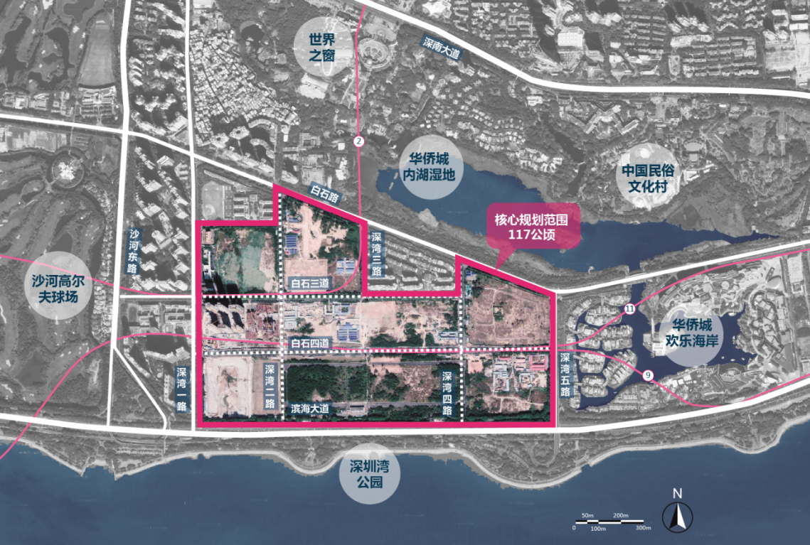
图1 核心研究范围
Fig. 1 Core Research Scope
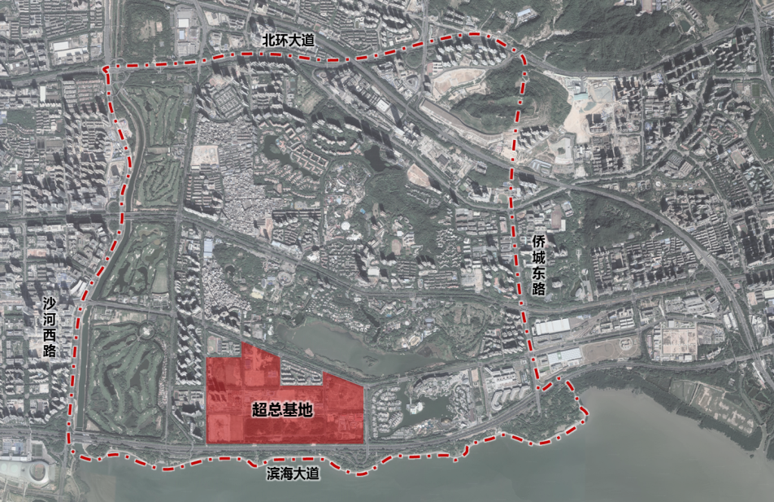
图2 规划研究范围
Fig. 2 Research Scope

原则与目标Principles and Goals
- 结合超总片区规划定位及发展目标，优化选择交通发展模式，明确片区综合交通体系发展目标和策略，并进行路网承载力测试，支撑片区超高强度开发需求。
In combination with the planned positioning and development goals of Shenzhen Bay Super Headquarters Base, optimize and choose its traffic development mode, define the development goal and strategy of the area's comprehensive transportation system, and carry out load capacity test for the roads network, to support the area's demand for a ultrahigh-strength development.
- 结合片区综合交通发展目标及策略，重新梳理规划路网、轨道、枢纽、常规公交、慢行、停车、交通管理及交通智慧化等系统，构建完善的片区综合交通运输体系。
In combination with the comprehensive traffic development goal and strategy of Shenzhen Bay Super Headquarters Base, rearrange and plan the roads network, urban railway, hubs, conventional buses, slow traffic, parking, traffic management, smart traffic and other systems to establish a complete comprehensive traffic system in the area.
- 配合片区综合交通规划开展轨道、枢纽及重要道路（含地下道路）交通详细规划，稳定其空间布局、组织方式、落实方案可行性，协同各类交通设施与片区城市设计、地下空间的相互关系，并指导下阶段工程设计。
In coordination with the comprehensive transportation planning of the area, carry out detailed traffic planning of urban railway, hubs and important roads (including underground roads), stabilize its spatial layout, organization mode and feasibility of this planning, coordinate the mutual relations between various traffic facilities and the urban design as well as the underground space of the area, and guide the construction design of the next phase.
- 结合滨海大道下穿计划、地下轨道现状与未来规划，统筹地下与地面空间交通规划，以现有创新科技手段，打造立体交通模式。
In combination with the Binhai Boulevard underpass project as well as the current status and future planning of underground railway, coordinate the traffic planning of underground and ground space, and build a three-dimensional traffic mode with existing innovative technological means.
（5）结合片区综合交通规划方案，协同城市设计与地下空间，对片区整体地下道路的网络规划、详细设计及交通建设运营开展全过程咨询，提出整体解决方案。
In combination with the comprehensive transportation plan of the area, coordinate with the urban design and underground space, carry out whole-process consulting on network planning, detailed design, traffic construction and operation of the whole underground roads in the area, and propose an overall solution accordingly.

3.工作内容 Planning Content
本次交通专项国际咨询主要包括四大块具体内容：
This international consultation on transportation mainly includes four parts:

3.1明确片区综合交通运输体系发展目标和策略 Define the Development Goal and Strategy of the Area's Comprehensive Transportation System
收集相关资料，开展现状调查调研，对交通现状分析与评估，对用地开发与交通基建进行定量评估分析和交通需求预测，制定综合交通体系发展目标、交通方式结构，提出交通发展政策和策略。
Collect relevant data, carry out investigation and research on its current status, analyze and evaluate the current traffic status, carry out quantitative evaluation and analysis on land development and traffic infrastructure construction as well as the traffic demand forecasting, draw up the development goal and structure of traffic modes of the comprehensive transportation system, and propose the traffic development polices and strategies.

3.2开展综合交通体系规划 Carry out the Comprehensive Transportation System Planning
开展片区道路交通系统规划（含地下道路）；轨道线网优化布局规划；常规公交线网、场站、停靠站及公交专用道布局规划；枢纽布局和用地规模控制规划、空中、地面及地下慢行系统规划；停车系统规划；交通管理与交通智慧化规划；地下交通规划；并进行方案评估，提出实施计划。
Carry out the road traffic system planning (including underground roads) for the area; layout optimization planning of urban railway transit network; layout planning of conventional bus network, stations, stops and bus transit lanes; planning of hubs layout and land scale control as well as above-ground, ground and underground slow-traffic system planning; planning of parking system; planning of traffic management and smart traffic; planning of underground traffic; carry out evaluation on the planning and propose the implementation plan.

3.3交通详细规划Detailed Transportation Planning
交通详细规划包括地面道路交通详细规划、地下道路交通详细规划、轨道及公交详细规划三部分内容。
The detailed transportation planning includes three parts, namely, the detailed traffic planning of ground roads, detailed traffic planning of underground roads, and detailed planning of urban railway and buses.
- 地面道路交通详细规划 Detailed Transportation Planning of Ground Roads
针对超总片区内部所有地面道路，提出平面、纵断面、横断面及交叉口渠化方案等，达到修建性详细规划深度。
As for all interior ground roads of Shenzhen Bay Super Headquarters Base, propose the plane, longitudinal and transverse section design as well as the canalization of intersections, etc., which shall reach the constructional detailed planning depth.
- 地下道路交通详细规划 Detailed Transportation Planning of Underground Roads
在片区内部地下道路网络布局方案基础上，提出地下道路平面、纵断面、横断面、竖向控制标高及地库出入口衔接方案，达到修建性详细规划深度。
On the basis of the layout scheme of interior underground roads in the area, propose the scheme for the plane, longitudinal section, transverse section, and vertical elevation, as well as connection with the access to basements, which shall reach the constructional detailed planning depth.
- 轨道及公交详细规划 Detailed Transportation Planning of Urban Railway and Buses
开展轨道线站位详细规划，提出详细的轨道线路选线方案、站点设置详细方案及换乘概念性人流组织方案；开展中运量公交线站位详细规划，对采用的系统模式进行论证分析，提出详细的中运量线路选线方案和站点设置详细方案；开展公交场站详细规划，提出公交场站详细选址方案。
Carry out detailed railway station location planning, propose a detailed railway line selection scheme, a detailed station setting scheme and a conceptual flow organization scheme during transfer; carry out detailed planning of stations for medium-volume bus lines, demonstrate and analyze the adopted system mode, and bring forward a detailed medium-volume line selection scheme and a detailed scheme for station setting; carry out detailed planning of bus stations and propose the detailed site selection scheme of bus stations.

3.4地下道路运营管理模式研究 Research on the Operation and Management Mode of Underground Roads
调研国内外地下道路、地下环路及类似工程的运维模式、建设模式，分析比较各类模式的优缺点、适应性和针对性。研究划定地下道路各阶段（权责）界面，并对界面两侧相关问题进行分析协调，提出合理的运营维护方案和资金筹措（即投资界面划分）方案，并细化日常运行及养护维修的作业模式、作业要求、作业流程及作业台帐。在联动管控机制的基础上，制定地下道路的智慧化管控方案并提出协同管理方案，对多主体的跨界管理体系进行整合。
Investigate the maintenance and operation mode as well as the construction mode of underground roads, underground loops and similar projects at home and abroad, analyze and compare the advantages and disadvantages, adaptability and pertinence of various modes. Study and determine the interface in each section (ownership) of underground roads, and analyze and coordinate relevant problems on both sides of the interface, to propose a reasonable operation and maintenance scheme and fund raising (that is, division of investment interface) scheme, and detail the operation mode, operation requirements, operation process and operation account of daily operation and maintenance. On the basis of linkage control mechanism, formulate the intelligent control scheme of underground roads; and propose the coordinated management scheme to integrate the cross-border management system of multiple subjects.

4.成果构成 Composition of Deliverables
本次国际咨询研究成果地面部分达到修建性详细规划标准要求、地下部分达到控制性详细规划标准要求（与同期开展的城市设计成果的深度相匹配），提交的成果内容包括但不限于以下内容：
As for the deliverables of this international consultation, the ground-level part shall meet the requirements of detailed constructional planning standard and the underground part shall meet the requirements of detailed controlled planning standard (matching the depth of the deliverables of urban design carried out at the same time). The deliverables submitted shall include but not limited to the following:

4.1文本报告 Report
提出深圳湾超级总部基地片区综合交通系统规划、地面及地下道路交通详细规划、轨道、公交及枢纽详细规划、地下道路运营管理模式研究等内容。
Propose the comprehensive transportation system planning, detailed ground and underground roads traffic planning, detailed planning of urban railway, buses and hubs, and research on operation and management mode of underground roads, etc..

4.2成果图集 Drawings
（1）项目区域位置图 Project Location
（2）现状市域重大交通设施分布图 Current Distribution of Major Municipal Public facilities
（3）现状及规划土地利用图 Current and Planned Land Use
（4）现状及规划轨道网络布局图 Current and Planned Layout of Railway Network
（5）现状及规划公交网络及设施布局图 Current and Planned Bus Network and Layout of Bus Facilities
（6）现状及规划路网结构图 Current and Planned Structure of Roads Network
（7）现状及规划道路流量图Current and Planned Road Flow Charts
（8）现状及规划道路饱和度图 Current and Planned Road Saturation
（9）现状及规划步行系统网络布局图 Current and Planned Layout of Pedestrian System Network
（10）公共停车场布局规划图 Planned Layout of Public Parking Lots
（11）公交场站布局规划图 Planned Layout of Bus Stations
（12）枢纽布局规划图 Planned Layout of Hubs
（13）片区地下道路道路网络布局图Layout of Underground Roads Network
（14）片区进出交通组织图Entry and Exit traffic Organization of the Area
（15）地面道路平面图Plan of Ground Roads
（16）地面道路横断面图 Transverse Section of Ground Roads
（17）地下道路平面图 Plan of Underground Roads
（18）地下道路纵断面图 Longitudinal Section of Underground Roads
（19）地下道路横断面图 Transverse Section of Underground Roads
（20）轨道线站位平面图及竖向标高图 Plan and Vertical Elevation of Railway Station
（21）公交枢纽平面图、竖向标高图及内部交通组织图 Plan, Vertical Elevation and Interior Traffic Organization of Public Transit Hubs
（22）重要节点平面图 Plan of Key Nodes

4.3成果规格与数量 Specification and Quantity of Deliverables
（1）《超级总部基地片区综合交通提升规划与交通详细规划》文本报告及图集。A3规格（297mm×420mm），装订成本，一式8本，无篇幅限制要求；
Report and drawings of the Comprehensive Transportation Improvement Planning and Detailed Transportation Planning of Shenzhen Bay Super Headquarters Base. In A3 size (297mm×420mm), bound together in book form, with 8 copies, with no length limit;
（2）电子版光盘2套；
2 sets of CD-ROM;
（3）现场汇报演示文件：PPT或PDF格式，汇报时间控制在20分钟内（含翻译时间及多媒体播放时间）；
On-site presentation file: in the format of PPT or PDF, with the reporting time within 20 minutes (including translation and multimedia playing time);
（4）电子文件：U盘及光盘各提交一份，含规划研究报告（PPT、doc文件或可编辑的PDF文件）、规划图纸（CAD或300DPI的JGP或PDF文件）、多媒体演示系统（MP4、AVI或WMV格式），现场汇报演示文件（PPT或PDF文件）等。
Electronic files: one copy in USB and CD-ROM respectively, including the planning research report (PPT, doc file or editable PDF file), planning drawings (CAD or JGP or PDF files of 300DPI), multi-media presentation system (in the format of MP4, AVI or WMV), on-site presentation file (in the format of PPT or PDF), etc..
* 以上所有设计成果文字必须采用中英双语，中英文内容如有出入以中文为准。
* The text of all the above deliverables must be bilingual both in English and Chinese. If there is any discrepancy between Chinese and English, the Chinese version shall prevail.
* 设计机构须遵守中华人民共和国及地方政府和部门颁布的有关商业秘密保护的法律法规和管理规定，对甲方提供的技术、经济资料及有关信息予以保密。未经甲方书面允许，乙方不得向第三人泄露、转让甲方提供的技术、经济资料及有关信息，不得将乙方获得的甲方的有关资料与信息用于本次咨询设计以外的其他用途。如违反上述要求给甲方造成损失的，须赔偿甲方因此所遭受的全部损失。
* The design firms must abide by the laws, regulations and management regulations promulgated by the People's Republic of China and local governments and departments regarding the protection of business secrets, and shall keep the technical, economic and related information provided by Party A confidential. Without the written permission of Party A, Party B shall not disclose or transfer the technical, economic and related information provided by Party A to a third party, and shall not use relevant materials or information obtained from Party A for other purposes other than this International Consultation. In case of any loss to Party A in violation of the above requirements, Party B shall compensate for all the losses incurred to Party A.

